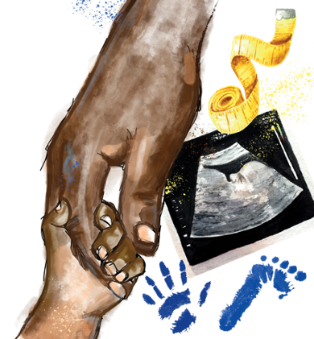

  
**Big Idea:** Cells are alive

What will I be   
learning about?

**What does this mean?**

One of the fundamental concepts in biology is that cells are alive. Cells are the building blocks of all living organisms so are crucial to many biological ideas. There are many different types of cell, which you will learn about through the next few years, as well as how they are involved in different biological areas.

**What is this unit about?**

****In this unit you will be learning about the structure of prokaryotic and eukaryotic cells and how cells transport substances. You will also be learning about the process of cell division, as well as starting to learn about how cancer forms. You will also learn about stem cells and their possible uses.

What should I already know?

Animal cells contain a nucleus, cytoplasm, cell membrane and mitochondria.

Plant cells contain these organelles as well as a cell wall, chloroplasts and a vacuole.

Each organelle has a specific function.

Microscopes are used to view objects that could not be seen by the naked eye.

Specialised cells have structures that are related to their functions.

Cells are organised into tissues, organs and organ systems.

Unicellular organisms are made up of one cell only.

Multicellular organisms are made up of any number of cells.

Growth and Differentiation

How do bacteria spread? What does a virus look like under a microscope? How do substances move between cells? What causes cancer?

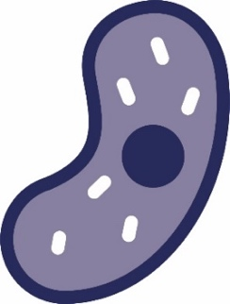All living things are made of cells, with many working together as tissues, organs and organ systems. The exchange of substances between cells and their environment allows the life processes   
to occur, fuelled by the organelles within. Differentiated cells allow living things to thrive in a huge variety of habitats.

This is the **second** unit we are studying as part of the big idea: **Cells are Alive**

In this unit, we will learn more about cell structure and specialisation. We will learn to classify cells as eukaryotic or prokaryotic according to some basic features and revisit the function of the main organelles (e.g. nucleus). We will learn how scientists now use electron microscopes to study cells in more detail. We will then learn about the three main methods of cell transport: diffusion, osmosis and active transport. We will study how different cells are adapted for efficient exchange and apply this learning about methods of cell transport to different examples.

Finally, we will study cell specialisation and learn how cells divide by mitosis to allow for growth and repair. We will learn that cancers are a group of diseases that can arise from uncontrolled cell growth. We will also learn how scientists use stem cells to study and treat different diseases.

We will develop our mathematical skills when we practise using the equation for calculating magnification. We will also learn how to use calculations to represent how rapidly bacteria can divide.

We will develop our practical enquiry skills by investigating bacterial growth using agar plates. We will practise using aseptic technique to safely grow bacteria. We will also have another opportunity to use microscopes to investigate cells. Finally, we will investigate how osmosis causes plant tissue to swell.

TASKS:  
What subject will this unit focus on? (circle the correct subject)

BIOLOGY CHEMISTRY PHYSICS

There are lots of keywords underlined above. List these into the two columns:

|  |  |
| --- | --- |
| Words I know | Words I haven’t seen before |
|  |  |

To answer before the unit:

1. What are you most excited to learn about in this topic?

________________________________________________________________________

________________________________________________________________________

________________________________________________________________________

1. What do you already know about this topic?

________________________________________________________________________

________________________________________________________________________

________________________________________________________________________

1. Why do you think it’s important to learn that cells are alive?

________________________________________________________________________

________________________________________________________________________

________________________________________________________________________

1. What knowledge from previous science lessons might help us?

________________________________________________________________________

________________________________________________________________________

________________________________________________________________________

1. What questions do you have about this topic?

________________________________________________________________________

________________________________________________________________________

________________________________________________________________________

To answer at the end of the unit:

1. Tick off any words in the ‘words I haven’t seen before’ column that you are now confident with. Circle any you still need more practice to use.
2. What have you most enjoyed about this unit?

______________________________________________________________________

______________________________________________________________________

______________________________________________________________________

1. What more would you like to learn about as part of the big idea: ‘cells are alive’?

______________________________________________________________________

______________________________________________________________________

****This multiple choice assessment will check that you are ready to start learning about this unit. Take this quiz without any help.

Pre-Test

When you’ve finished, check the answers on the next page and complete any ‘fix-it’ tasks before moving on to learn the new topic.

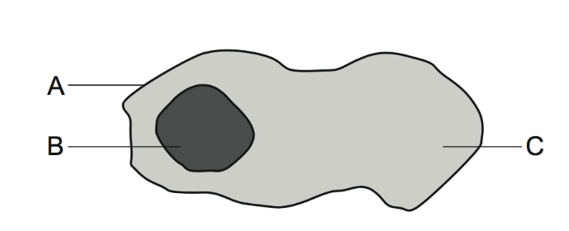1. The diagram below shows a cell. What is the name of the part labelled A?

A. Cell wall

B. Cytoplasm

C. Cell membrane

2. What is the function of the part labelled B?

A. Controls what enters and leaves the cell.

B. Contains DNA and controls activities in the cell

C. Makes food for the cell using light

3. Which statement is correct about cytoplasm?

A. Cytoplasm is only found in animal cells

B. Cytoplasm is only found in plant cells

C. Cytoplasm is found in both animal and plant cells

4. A type of yeast is used to bake bread. The yeast is made of single cells. Which statement best describes these yeast cells?

A. Yeast is a unicellular organism

B. Yeast is a multicellular organism

C. Yeast is made of plant cells

5. A student uses a microscope to magnify a specimen from a leaf. Iodine solution is used to stain the specimen. The diagram shows what the student saw in the microscope. Which correctly describes how this diagram could be improved?

A. Draw more cells so more of the tissue can be seen

B. Increase the magnification

C. Add labels for the nucleus, cell membrane and cytoplasm

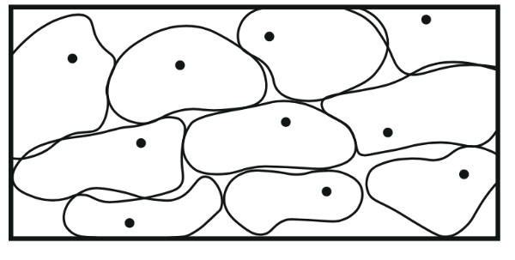6. Why are microscopes needed to see cells?

A. Cells are see-through so cannot be seen by eye

B. Cells are too small to be seen by eye

C. Cells can only be seen on a slide

7. How would the student magnify one cell to study it in more detail?

A. Move the coarse focus wheel

B. Change the eye piece lens to a greater magnification

C. Change the objective lens to a greater magnification

8. The student thinks that the dot seen in each cell is a chloroplast. Do you agree with the student?

A. Yes

B. No

C. Need more information

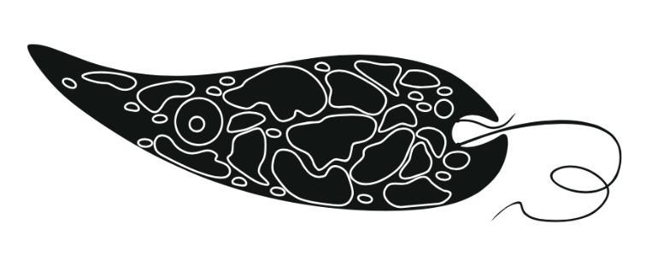9. The diagram below shows a cell called *Euglena*. How is the cell adapted for moving?

A. It has a tail

B. It moves to get food

C. It is a sperm cell

10. The cell makes food using sunlight. Which part of the cell carries out this process?

A. Cytoplasm

B. Chloroplast

C. Vacuole

End of Unit Pre-Test. Turn over to see the answers. Give yourself a mark out of 10.



Pre-Test Answers

|  |  |  |
| --- | --- | --- |
| Question | Answer | What to do next (Fix-It task) |
| 1 | C | If you answered A or B you need to review the different organelles in plant and animal cells. Label each part of the diagram in Q1. |
| 2 | B | If you answered A or C you need to review the functions of the cell organelles. Explain the functions of each of the organelles that are found in both plant and animal cells. |
| 3 | C | If you answered A or B you need to review the functions of the cell organelles. Explain the functions of each of the organelles, including those that are only found in plant cells. |
| 4 | A | If you answered B or C you need to review the difference between unicellular and multicellular organisms. Explain the difference between these terms and give an example of each. |
| 5 | C | If you answered A or B you need to review how to draw a good scientific drawing. Describe how to draw a good scientific drawing. |
| 6 | B | If you answered A or C you need to review the function of a microscope and the relative scale of cells. Explain why microscopes are used to see cells. |
| 7 | C | If you answered A or B you need to review the functions of the different parts of a microscope. Describe the functions of the eyepiece lens, the objective lens, the coarse focusing wheel and the fine focusing wheel. |
| 8 | B | If you answered A or C you need to review the structure of plant and animal cells. Describe the differences between plant and animal cells. |
| 9 | A | If you answered B or C you need to review the relationship between structure (adaptation) and function. Explain how the structure of a neuron makes it well suited to its function. |
| 10 | B | If you answered A or C you need to review the functions of different organelles. State the word equation for photosynthesis and the organelle that it takes place within. |

Great job! Now you’re ready to start learning about growth and differentiation!



Knowledge   
Organiser

1. **Eukaryotic cells** have membrane-bound organelles and have genetic material contained in the nucleus
2. An **organelle** is a part of a cell that carries out a specific function
3. Plant and animal cells are examples of **eukaryotic cells**
4. Eukaryotic cells are typically between **10-100 μm** in size
5. All eukaryotic cells have a nucleus, mitochondria, ribosomes, cytoplasm and a cell membrane. Plant cells also have a cell wall, vacuole and chloroplasts
6. **Mitochondria** are the site of aerobic respiration which releases energy for cellular processes
7. **Ribosomes** are the site of protein synthesis
8. **Prokaryotic cells** do not contain membrane-bound organelles
9. Prokaryotic cells are approximately 10 orders of magnitude smaller than eukaryotic cells
10. Prokaryotic cells contain genetic material in small rings called **plasmids**, or in larger loops
11. 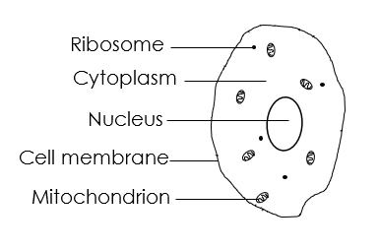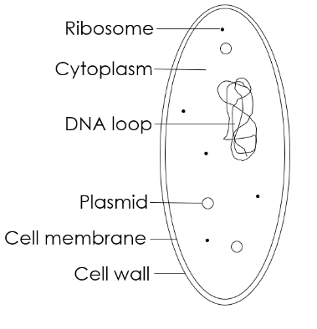Prokaryotic ribosomes are smaller than eukaryotic ribosomes
12. Petri dishes are used to produce **cultures** of bacteria and other micro-organisms
13. Cultured bacteria are grown on a **nutrient medium** in controlled conditions
14. **Aseptic techniques** must be used to prepare cultures to prevent contamination of the culture and the growth of harmful bacteria
15. Petri dishes, inoculating loops and culture media must be sterilised before use. A flame can be used to sterilise equipment
16. An **inoculating loop** is a piece of equipment used to transfer bacteria to the petri dish
17. The lid of a Petri dish should be partially secured with tape to ensure bacteria cannot escape but conditions remain aerobic
18. The Petri dish must be stored upside down to prevent condensation affecting bacterial growth
19. In school laboratories, cultures should generally be incubated at **25 °C** to prevent the growth of harmful bacteria
20. A cotton wool swab can be used to transfer a sample to a Petri dish to investigate bacterial growth
21. Bacteria on a Petri dish divide rapidly whilst the nutrient supply is rich. Every time the bacteria reproduce, the number doubles. The total number of bacteria can be calculated using the following formula:

**Final number of bacteria = Initial number of bacteria x 2 number of divisions**

Microscopy

1. **Microscopy** is the field of using microscopes to view samples that cannot be seen with the naked eye
2. **Light microscopes** allow us to see the largest organelles, including the nucleus, cell membrane, cell wall and cytoplasm. A **stain** is often used to make the organelles clearer
3. The parts of a light microscope include the eyepiece lens, objective lenses, stage, coarse focusing wheel, fine focusing wheel, light/mirror
4. A sample used with a light microscope must be very thin to allow light to pass through
5. The total magnification of a microscope can be calculated using the following equation:

**Total magnification = Objective lens x eyepiece lens**

1. **Electron microscopes** have a greater magnification and resolution than light microscopes. They are much more expensive than light microscopes
2. **Magnification** is the number of times larger an image is than the object
3. **Resolution** is the ability to distinguish between two points
4. Electron microscopes allow are to see more organelles and study cells in greater detail
5. **Magnification** can be calculated using the following equation:

|  |  |
| --- | --- |
| Magnification = | Size of image |
| Actual size of object |

1. A **scale bar** can be used to calculate the magnification of an irregular object
2. Magnification does not have a unit because it is a ratio

Transport of substances

1. Shape

   Description automatically generated with medium confidence**Diffusion** is the spreading out of particles, of a gas or liquid, resulting in net movement from an area of high concentration to low concentration
2. In gas exchange, oxygen and carbon dioxide diffuse between the alveoli and the blood
3. The **rate of diffusion** is increased by:

* an increase in temperature
* an increase in the difference in concentrations (**concentration gradient**)
* a greater surface area

1. **Unicellular organisms** have a relatively high **surface area to volume ratio** allowing for sufficient transport of all required substances
2. Large, **multicellular organisms** have adaptations to increases the surface area to volume ratio to allow for efficient exchange of substances
3. Diagram

   Description automatically generated**Osmosis** is the diffusion of water from a **dilute solution** to a **concentrated solution** through a **partially permeable membrane**
4. A **partially permeable membrane** is a membrane that lets particular substances pass through it, either into or out of the cell
5. A **hypertonic solution** is one in which the external solution has a higher concentration of solute than the cell. Water always moves out of a cell that is placed in a hypertonic solution, causing the cell to shrivel or become **flaccid**
6. Tissue placed in hypertonic solutions decreases in mass
7. A **hypotonic solution** is one in which the external solution has a lower concentration of solute than the cell. Water always moves into a cell that is placed in a hypotonic solution, causing the cell to swell or become **turgid**
8. Tissue placed in hypotonic solutions increases in mass
9. An **isotonic solution** is one in which the external solution has the same concentration of solute as the cell. Water will not move in or out of cells placed in an isotonic solution so their size will stay constant
10. 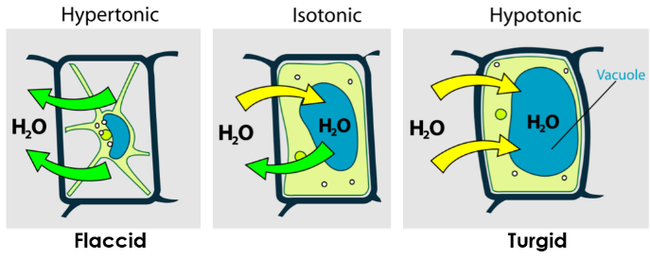**Guard cells** open and close due to the movement of water by osmosis
11. The mass of plant tissue can be measured before and after being placed in a solution of known concentration to calculate the **percentage change** in mass due to osmosis
12. **Active transport** moves substances from a more dilute solution to a more concentrated solution, requiring energy from respiration
13. Active transport works **against the concentration gradient**
14. 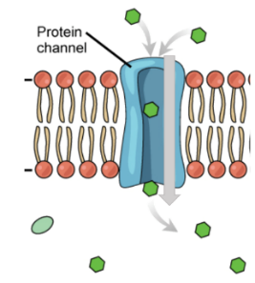Active transport is used in root hair cells to absorb mineral ions from the soil that are essential for plant growth

Cell division and differentiation

1. Both eukaryotic and prokaryotic cells undergo **cell division**
2. Cells increase in number by dividing into two
3. The **eukaryotic cell cycle** contains a **growth phase** where the cell grows to double sub-cellular structures (such ribosomes and cell membrane) and DNA, then the cell splits into two during **mitosis**
4. The length of time in a certain stage of the cell cycle can be calculated using the following formula:

(observed number of cells initial stage) X total length of time

(total number of cells observed) of cell cycle

1. The mass of **DNA** in a cell doubles during the growth phase of the cell cycle
2. During **mitosis** DNA (arranged into chromosomes) is pulled to separate ends of the cell ready for division
3. The final part of the cell cycle is when the cell membrane splits to produce two identical **daughter cells**
4. Mitosis is used by eukaryotic organisms for growth and repair and by those that reproduce asexually
5. Mitosis does not occur in prokaryotic cells because they do not possess a nucleus
6. **Checkpoints** in the cell cycle control the rate of cell division
7. **Cancer** is caused by uncontrolled cell division
8. A **tumour** is a mass of cells caused by **uncontrolled cell division**
9. 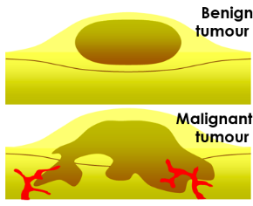**Benign tumours** are a mass of cells contained in one area
10. **Malignant tumours** are formed of cancer cells that invade other tissues and spread around the body where they form secondary tumours
11. A **risk factor** is a gene or lifestyle choice that can increase the likelihood of a person developing a disease
12. **Lifestyle risk factors** for cancer include poor diet, lack of exercise, smoking, UV exposure
13. **Genetic risk factors** for cancer include gene mutations
14. Specialised cells arise from **stem cells**
15. Stem cells are cells that are capable of **differentiating** into other types of cell
16. When a cell differentiates, it acquires specific structures needed for that cell type
17. Most animal cells differentiate at an early stage of development
18. **Embryonic stem cells** can differentiate into all human cell types
19. **Adult bone marrow** contains stem cells that can differentiate into different types of blood cell
20. Embryonic stem cells can be used to study and treat diseases. There are **religious and ethical objections** to using embryonic stem cells in scientific research
21. Plants contain **meristem tissue** at the tips of shoots and roots that retains the ability to differentiate throughout a plant’s life



Glossary

**Active transport** The movement of molecules from a dilute to a more concentrated solution against a concentration gradient using energy from respiration.

*Mineral ions move into root hair cells using* ***active transport****.*

**Adaptation** Something (e.g. a structure or a shape) that enables a specialised cell to carry out its function.

*One* ***adaptation*** *that a sperm cell has to its function, is having a tail which allows it to swim.*

**Agar medium** A jelly like substance containing all the nutrients needed to culture microorganisms.

*Students cultured bacteria in the lab using* ***agar medium.***

**Aseptic** Free from contamination of microorganisms.

*The* ***aseptic*** *technique is used to prevent contamination of agar plates.*

**Antibiotic** A drug that is used to treat bacterial infections.

*The doctor prescribed an* ***antibiotic*** *for the patient’s bacterial infection.*

**Benign** A ‘safe’ tumour where the mass of cells is contained to one area.

*The tumour was* ***benign*** *because it could not spread around the body.*

**Bone marrow** The spongy centre of long bones, where blood cells are produced.

*Adult stem cells can be extracted from bone marrow.*

**Cancer** When cell division happens uncontrollably so cell numbers increase rapidly and can form tumours.

***Cancer*** *is a disease that is affected by lifestyle and genetic risk factors.*

**Chromosome** A structure found in the nucleus made of DNA.

*Human body cells contain 23 pairs of* ***chromosomes.***

**Concentration gradient** The difference in concentrations of a substance between two areas.

*The larger the* ***concentration gradient*** *the faster the rate of diffusion.*

**Culture** The growing of microorganisms (such as bacteria) for scientific study.

*We can grow a* ***culture*** *of bacteria on an agar plate.*

**Differentiate / differentiation** When cells acquire the specific structures needed for that cell type.

*Most animal cells* ***differentiate*** *in the early stages of embryo development.*

**Diffusion** The movement of particles from a high concentration to a low concentration.

*Oxygen travels from the alveoli into the blood via* ***diffusion****.*

**Embryonic** From an embryo or developing baby.

***Embryonic*** *stem cells can develop into all human cell types.*

**Eukaryotic** A cell that contains membrane bound organelles.

*Plant and animal cells are both types of* ***eukaryotic*** *cells or* ***eukaryotes****.*

**Flagellum** A whip-like structure found in some prokaryotic cells.

*The bacteria have* ***flagella*** *to enable them to move.*

**Hypertonic** **solution** A solution in which the external solution has a higher concentration of solute than the cell.

*When a cell is placed in a* ***hypertonic******solution*** *water will move out of the cell by osmosis.*

**Hypotonic** **solution** A solution in which the external solution has a lower concentration of solute than the cell.

*When a cell is placed in a* ***hypotonic******solution*** *water will move into the cell by osmosis.*

**Inoculating** **loop** A piece of apparatus used to transfer a sample of microorganism to an agar plate.

*The* ***inoculating******loop*** *must be sterilised before use to prevent contamination.*

**Isotonic** **solution** A solution in which the external solution has the same concentration of solute as the cell.

*If a cell is placed in an* ***isotonic solution*** *there will be no net movement of water.*

**Magnify / magnification** The process of enlarging the image of an object.

*Microscopes are used to* ***magnify*** *objects.*

**Malignant** Tumours that have the potential to spread around the body and invade other tissues.

*The tumour was* ***malignant*** *as it spread to other organs.*

**Meristem** Stem cells found in plants that can develop into all plant cells.

***Meristems*** *are found at the very tips of root and shoots in plants.*

**Mitochondria** A membrane bound structure in a cell that is the site of aerobic respiration.

*Muscle cells contain many* ***mitochondria*** *because they require a high amount of energy.*

**Mitosis** The phase of cell division when one cell divides into two.

*After DNA is replicated in the cell cycle,* ***mitosis*** *occurs.*

**Nucleus** A membrane bound structure in a cell that contains DNA and controls the cell’s activities.

*The* ***nucleus*** *is one of the largest organelles in the cell.*

**Organelle** A sub-cellular structure that has a specific function inside the cell.

*Mitochondria are the* ***organelles*** *where aerobic respiration takes place.*

**Partially permeable membrane** A membrane that lets particular substances through it (either in or out).

*Cell membranes are examples of* ***partially permeable membranes****.*

**Passive** A process that does not require energy.

*Diffusion and osmosis are* ***passive*** *processes.*

**Plasmid** A small piece of circular DNA located in a prokaryotic cell.

*Prokaryotes do not have a nucleus, instead their DNA can be found in* ***plasmids****.*

**Prokaryotic** A cell which does not contain membrane bound organelles.

*Bacteria are* ***prokaryotic*** *cells or* ***prokaryotes****.*

**Risk** **factor** A lifestyle or genetic factor that increases an individual’s risk of developing a disease.

*Smoking is a* ***risk factor*** *for lung cancer.*

**Resolution** The ability to distinguish between two points in an image.

*The image was blurry because it had a low* ***resolution****.*

**Specialised** Adapted to a specific function or job.

***Specialised*** *cells have different adaptations to carry out specific functions.*

**Specimen** An individual sample of an organism for scientific study.

*Living and dead* ***specimens*** *can be viewed under a microscope.*

**Stem cell** An undifferentiated cell that can form other cell types.

***Stem******cells*** *could be used to treat paralysis.*

**Sub-cellular** Structures found within a cell.

*The nucleus is a* ***sub-cellular structure****.*

**Surface** **area** The outside surface of an object.

*The* ***surface******area*** *of the leaf was large so it could absorb lots of sunlight.*

**Surface area to volume ratio** Can be calculates by dividing the surface area by the volume of an object.

*Small objects have a larger* ***surface area to volume ratio*** *than larger objects.*

Do Now:

New Learning

Prior Knowledge Review

1. State the life processes.

________________________________________________________________________

1. Explain the difference between unicellular and multicellular organisms.

________________________________________________________________________

1. Explain what a microscope is used for.

________________________________________________________________________

1. State the organelles that are found in plant cells but not animal cells.

________________________________________________________________________

1. Name the organelle that is the site of aerobic respiration.

________________________________________________________________________

**Foundation:** List the organelles that can be found in a plant cell.

________________________________________________________________________

**Stretch:** Describe how a sperm cell is adapted for its function.

________________________________________________________________________

________________________________________________________________________

1. 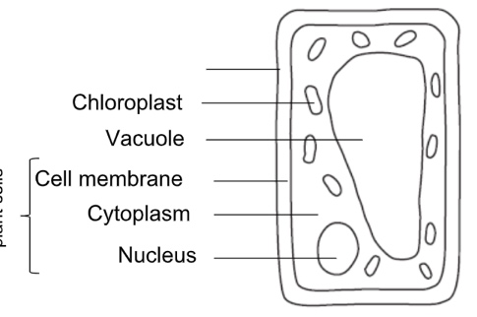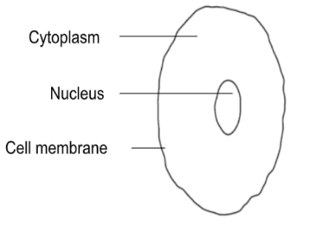Label the diagrams to show the organelles found in an animal cell and a plant cell.

Activities

and Practice

1. State the function of each of the organelles
2. Nucleus

_____________________________________________________________________

1. Cytoplasm

_____________________________________________________________________

1. Cell membrane

_____________________________________________________________________

1. Chloroplast

_____________________________________________________________________

1. Vacuole

_____________________________________________________________________

1. Cell wall

_____________________________________________________________________

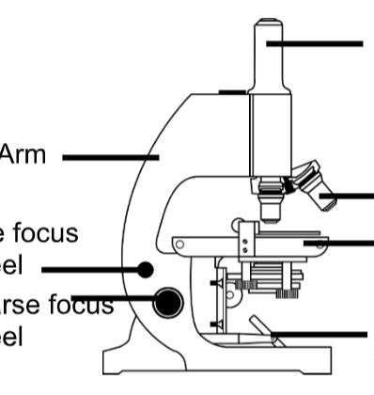3. Add the following labels to the light microscope:

* Eyepiece lens
* Objective lens
* Arm
* Fine focus wheel
* Coarse focus wheel
* Stage
* Light source

4. Describe the steps you would follow to view a cell sample under this microscope.

________________________________________________________________________

________________________________________________________________________

________________________________________________________________________

________________________________________________________________________

________________________________________________________________________

________________________________________________________________________

________________________________________________________________________

________________________________________________________________________

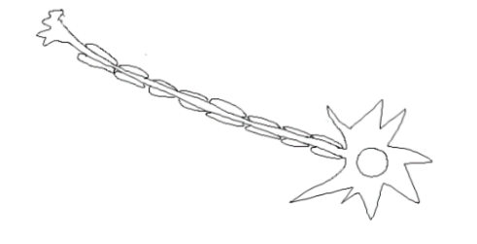5. State the function of each of the specialised cells below and how its structure is adapted for its function:

Sperm cell  
Function:

Structure:

Neuron (Nerve cell)  
Function:

Structure:

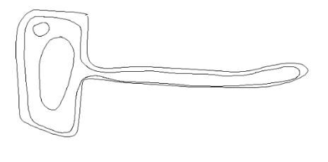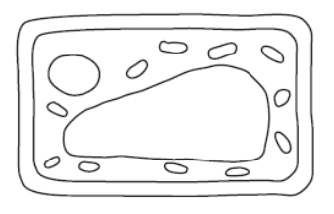

Leaf cell  
Function:

Structure:

Root hair cell  
Function:

Structure:

6. Write the correct keyword for each definition:

* A group of the same cells working together ____________
* A group of tissues working together for the same function ____________
* A group of organs working together for the same function ___________

**Stretch**:

List the organ systems that make up the human body with the function and organs involved in each one.

________________________________________________________________________

________________________________________________________________________

________________________________________________________________________

________________________________________________________________________

________________________________________________________________________

________________________________________________________________________

________________________________________________________________________

________________________________________________________________________

1. Which organelles do plant cells have but animal cells do not?

Exit Ticket

A. Nucleus, cell membrane and cytoplasm

B. Cell wall, vacuole, chloroplasts

C. Chloroplasts, cell membrane, nucleus

2. Which is the best explanation for the function of a microscope?

A. To make small objects easier to see

B. To see objects that are very far away

C. To make big objects seem smaller

3. Which statement has the organelle correctly matched with its function?

A. Cell wall, controls what enters and leaves the cell

B. Chloroplast, absorbs sunlight for respiration

C. Nucleus, controls cell’s activities and contains genetic information

For question 3, read the guidance below and carry out the ‘fix-it’ task which has been set for you.

If you answered A

The cell wall is an organelle that is only found in plant cells, where it provides structure and support. The cell membrane is found in both animal and plant cells and controls what substances enter and exit the cell.

*State the organelles that are found in plant cells only and explain each of their functions.*

If you answered B

Chloroplasts are organelles that are found only in plant cells, as they are responsible for absorbing sunlight. This sunlight is needed for the process of photosynthesis, the method by which plants use sunlight to make their own food in the form of glucose.

*State the word equations for photosynthesis and respiration and explain why photosynthesis cannot take place in animal cells.*

If you answered C

The nucleus is found in both animal and plant cells. It contains the genetic material in the form of DNA arranged in chromosomes. This DNA codes for specific proteins to be made which is how the nucleus controls cell activities.

*Describe how the nucleus of a human body cell is different to the nucleus of a gamete (sperm or egg cell).*

Do Now:

New Learning

Eukaryotic and Prokaryotic Cells

1. Explain how neurons are well suited for their function.

________________________________________________________________________

1. Explain the difference between the coarse focusing wheel and the fine focusing wheel on a light microscope.

________________________________________________________________________

1. State the word equation for aerobic respiration.

________________________________________________________________________

1. Explain why it is incorrect to say that energy is made during respiration.

________________________________________________________________________

1. Name the organelles that are found in plant cells only.

________________________________________________________________________

**Foundation:** Name the organelle that is the site of photosynthesis.

________________________________________________________________________

**Stretch:** Red blood cells have an extremely large surface area. How does this help them carry out their function?

________________________________________________________________________

________________________________________________________________________

There are two types of cell – **eukaryotic** and **prokaryotic**.

Eukaryotic cells contain genetic material (DNA) within a **nucleus.**

**Plant** and **animal** cells are eukaryotic. The organelles in eukaryotic cells are contained within membranes (you may hear these referred to as ‘membrane-bound organelles’).

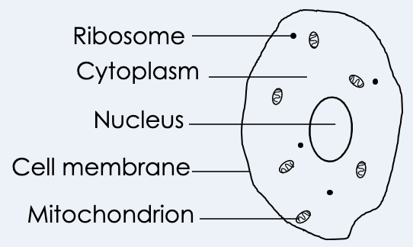Eukaryotic cells usually contain **mitochondria** (sing. mitochondrion) to provide energy for the cell through aerobic respiration.

Eukaryotic cells are typically between 10-100 μm in size, meaning they are much **larger** than prokaryotic cells. The word eukaryotic comes from eu (which means true or real) and karyo (which means kernel or nut – in this case nucleus).

Prokaryotic cells contain genetic material (DNA) in small rings called **plasmids**, or in larger loops (called nucleoids).

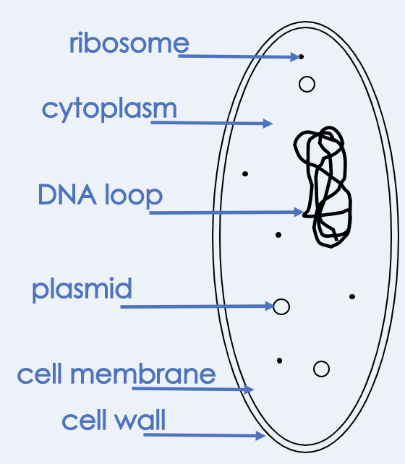**Bacterial** cells are an example of prokaryotic cells. Prokaryotic cells do not contain membrane-bound organelles, but they often contain flagella (sing. flagellum) to help them move.

Prokaryotic cells are much smaller than eukaryotic cells, typically 1-10 μm in size.

Both eukaryotic and prokaryotic cells contain **ribosomes**, which make proteins for the cell.

1. Determine if each statement is true or false:

Activities

and Practice

1. Eukaryotic cells are bigger than prokaryotic cells
2. Prokaryotic cells contain their genetic information in a nucleus
3. Bacteria are prokaryotic cells
4. Plant cells are prokaryotic cells
5. Eukaryotic cells can contain mitochondria to provide energy through aerobic respiration
6. Draw a simple animal cell and a simple plant cell and add the following labels to your eukaryotic cells (where necessary):

* Nucleus
* Cell membrane
* Mitochondria
* Ribosomes
* Cell wall
* Chloroplasts
* Cytoplasm
* Permanent vacuole

1. Use your previous knowledge and information about each feature to help you label this prokaryotic bacterial cell:

* **Genetic material** – in the form of a loop of DNA not found in a nucleus
* **Cytoplasm** – jelly-like substance where chemical reactions occur
* **Flagella** – whip-like structures that allow the bacteria to move around
* **Cell** **wall** – provides structure and support to the cell
* **Capsule** – slimy outer layer that provides protection to the cell
* **Cell** **membrane** – controls the entry and exit of substances to and from the cell
* 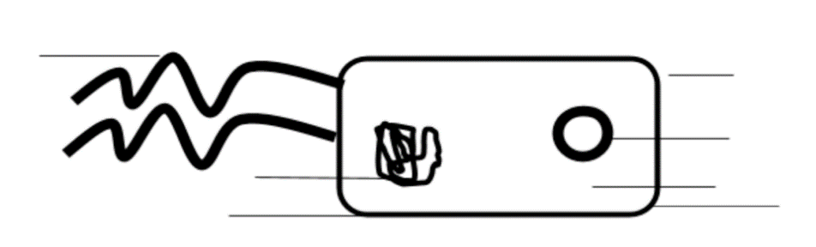**Plasmid** – small ring of DNA

1. Place ticks in the correct boxes to summarise the features that are found in each type of cell.

|  |  |  |  |
| --- | --- | --- | --- |
| Feature | Animal Cell | Plant Cell | Bacterial Cell |
| Nucleus |  |  |  |
| Plasmids |  |  |  |
| Cell membrane |  |  |  |
| Cell wall |  |  |  |
| Chloroplasts |  |  |  |
| Cytoplasm |  |  |  |
| Permanent vacuole |  |  |  |
| Flagella |  |  |  |

Stretch Activity

The image below shows a *Euglena* cell. *Euglena* is a unicellular organism. Decide if it is a prokaryotic or eukaryotic cell based on its features and explain your decision.

_______________________________________________

_______________________________________________

_______________________________________________

_______________________________________________

_______________________________________________

_______________________________________________

1. Which of these is an example of a prokaryotic cell?

Exit Ticket

A. Animal cell

B. Plant cell

C. Bacterial cell

2. What is the relative size of eukaryotic cells and prokaryotic cells?

A. Prokaryotic cells are larger than eukaryotic cells

B. Eukaryotic cells are larger than prokaryotic cells

C. Prokaryotic cells and eukaryotic cells are roughly the same size

3. Which statement best explains the difference between eukaryotic and prokaryotic cells?

A. Eukaryotic cells contain DNA within a nucleus, prokaryotic cells contain DNA in loops and plasmids

B. Eukaryotic cells contain DNA in loops and plasmids, prokaryotic cells contain DNA within a nucleus

C. Prokaryotic cells contain mitochondria to provide them with energy so they can move

For question 3, read the guidance below and carry out the ‘fix-it’ task which has been set for you.

If you answered A

Eukaryotic cells and prokaryotic cells all contain genetic material (DNA) but it is stored in different ways in each. In eukaryotic cells DNA is found within a nucleus, whereas in prokaryotic cells DNA is found in loops and plasmids.

*Explain what is meant by membrane-bound organelles and identify if eukaryotic cells and prokaryotic cells contain membrane-bound organelles.*

If you answered B

Eukaryotic cells and prokaryotic cells all contain genetic material (DNA) but it is stored in different ways in each. In eukaryotic cells DNA is found within a nucleus, whereas in prokaryotic cells DNA is found in loops and plasmids.

*Summarise the differences between eukaryotic and prokaryotic cells.*

If you answered C

Eukaryotic cells and prokaryotic cells all contain genetic material (DNA) but it is stored in different ways in each. In eukaryotic cells DNA is found within a nucleus, whereas in prokaryotic cells DNA is found in loops and plasmids. Both eukaryotic and prokaryotic cells contain mitochondria, which is where aerobic respiration happens, providing the cell with energy.

*Identify the part of prokaryotic cells that allows them to move and explain how this helps them to move.*

Do Now:

New Learning

Aseptic Technique

1. Explain the difference between eukaryotic and prokaryotic cells.

________________________________________________________________________

1. Explain the purpose of mitochondria in eukaryotic cells.

________________________________________________________________________

1. Give an example of a eukaryotic cell and prokaryotic cell.

________________________________________________________________________

1. Describe the difference between unicellular and multicellular organisms.

________________________________________________________________________

1. Give an example of a unicellular organism.

________________________________________________________________________

**Foundation:** State the function of the cell membrane.

________________________________________________________________________

**Stretch:** Compare the relative sizes of eukaryotic and prokaryotic cells and how you would investigate them under a microscope.

________________________________________________________________________

________________________________________________________________________

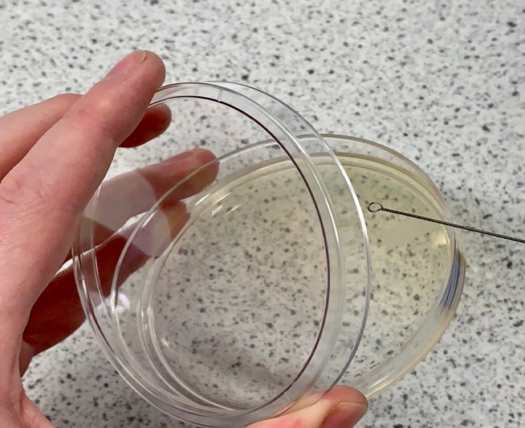Petri dishes are often used to produce cultures of **bacteria** and other microorganisms. These cultures have a number of uses but one of the most important uses is testing the effectiveness of antibiotics.

The **aseptic technique** must be used to prepare these cultures, to ensure that the equipment is not **contaminated** and allows one microorganism to be investigated at a time. This means that scientists are able to look specifically at the growth of one bacteria or microorganism at a time (and ensures there is only ever one independent variable).

The aseptic technique involves:

* Sterilising petri dishes and culture media (**agar**) before use – this is to destroy any microorganisms that may already have been present
* Agar medium in plates must be set – this agar (the yellow coloured jelly) provides a nutrient medium for the bacteria which allows it to grow.
* Inoculating loops (pictured) are used to transfer bacteria onto the agar, but must first be sterilised by passing them through a flame – this destroys any other microorganisms that may already be present on the loop
* The bacteria are applied to the agar (see method on practical instructions) with even coverage
* The lid of the petri dish should be secured with tape and stored upside down (but the tape should not go all the way around) – this means that oxygen can get in so the bacteria can respire, but no other microorganisms from the air can contaminate the culture
* In school laboratories the culture should be incubated at 25 °C – this allows the growth of the bacteria but minimises the chance of contamination by other microorganisms

Answer the following questions and carry out the practical to prepare a culture using the aseptic technique.

Activities

and Practice

1. Why is the aseptic technique used?

________________________________________________________________________

1. What is an inoculating loop used for?

________________________________________________________________________

1. Why is the inoculating loop passed through a flame first?

________________________________________________________________________

1. What temperature should cultures be incubated at?

________________________________________________________________________

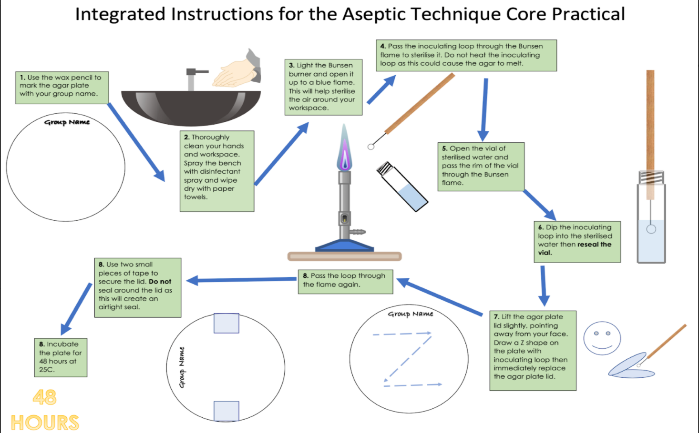

1. Which best explains why the aseptic technique is used?

Exit Ticket

A. To ensure that there is no contamination when preparing a culture

B. To ensure that the petri dish is clean

C. To ensure that all microorganisms are allowed to grow

2. Which is not a feature of the aseptic technique?

A. Sterilising the inoculating loop using a flame

B. Securing the petri dish by making an airtight seal

C. Sterilising the agar before use

3. What is the function of the agar in a petri dish?

A. To provide a nutrient medium.

B. To sterilise the petri dish.

C. To destroy any microorganisms

For question 1, read the guidance below and carry out the ‘fix-it’ task which has been set for you.

If you answered A

The aseptic technique is used to prepare cultures of microorganisms to investigate their growth and the effect of different factors on their growth. The aseptic technique ensures that only one microorganism is cultured at a time, meaning there is no contamination.

*Suggest what would happen if the aseptic technique was not used.*

If you answered B

The aseptic technique is used to prepare cultures of microorganisms to investigate their growth and the effect of different factors on their growth. The aseptic technique ensures that only one microorganism is cultured at a time, meaning there is no contamination. The petri dish must be sterilised, not just clean.

*Explain why the aseptic technique is important in preparing microorganism cultures.*

If you answered C

The aseptic technique is used to prepare cultures of microorganisms to investigate their growth and the effect of different factors on their growth. The aseptic technique ensures that only one microorganism is cultured at a time, meaning there is no contamination. If more than one microorganism was growing at a time this would be like having more than one independent variable.

*Describe how the aseptic technique allows the growth of one microorganism only.*

Do Now:

New Learning

Growth of Bacteria

1. Compare the sizes of eukaryotic and prokaryotic cells.

________________________________________________________________________

1. Describe the function of an inoculating loop.

________________________________________________________________________

1. Explain why the aseptic technique is used.

________________________________________________________________________

1. Name the type of cells that have genetic information stored in a nucleus.

________________________________________________________________________

1. Name the organelle that controls the entry and exit of substances into and out of cells.

________________________________________________________________________

**Foundation:** State the location of DNA in prokaryotic cells.

________________________________________________________________________

**Stretch:** Explain why prokaryotic cells have flagella.

________________________________________________________________________

________________________________________________________________________

Certain bacteria can cause diseases, some of which can be treated with **antibiotics** or **antiseptics**. This practical will investigate the effectiveness of different types of antibiotic by measuring how much the bacteria are allowed to grow. You will have seen from the culture that you produced using the aseptic technique that bacteria grow steadily over a 48 hour period. To determine how good an antibiotic is, we want to see how many bacteria it can destroy. If an antibiotic has destroyed the bacteria, the bacteria will not grow, which can be identified by a **clear zone** in the culture.

Calculating the area of the clear zone

* Measure the diameter of the clear zone using a ruler above the Petri dish
* Divide this by 2 (to give you the radius)
* Use the equation: A = *π r2*
* Remember to include units

Bacteria are able to divide and multiply rapidly, which is often why they can cause diseases. We can use their **mean division time** (how long it takes to undergo cell division) and how long the sample has been left to predict or calculate how many bacteria would be present.

Example:

Bacteria A has a mean division time of 30 minutes (half an hour). If the culture begins with one bacterium how many bacteria would you expect to be present after 12 hours?

1. Calculate how many divisions would have occurred in this time.

12 hours/0.5 hours = 24 divisions.

1. Every time the bacteria reproduce, the number doubles. Now use this equation:

**Final number of bacteria = Initial number of bacteria x 2number of divisions**

Final number = 1 x 224

= 16777216 bacteria (or 1.68 x107 in standard form)

1. What is the purpose of using the aseptic technique to prepare the petri dishes?

Activities

and Practice

1. It ensures the growth of as many types of bacteria as possible
2. It ensures that only the bacteria we are investigating is allowed to grow
3. It ensures that no bacteria grow at all
4. What will be investigated in this practical?
   1. The effectiveness of different antibiotics
   2. Which bacteria is the strongest
   3. The level of contamination
5. Which of these is not involved in the aseptic technique?
   1. Passing the inoculating loop through a flame
   2. Incubating the sample at 50 °C
   3. 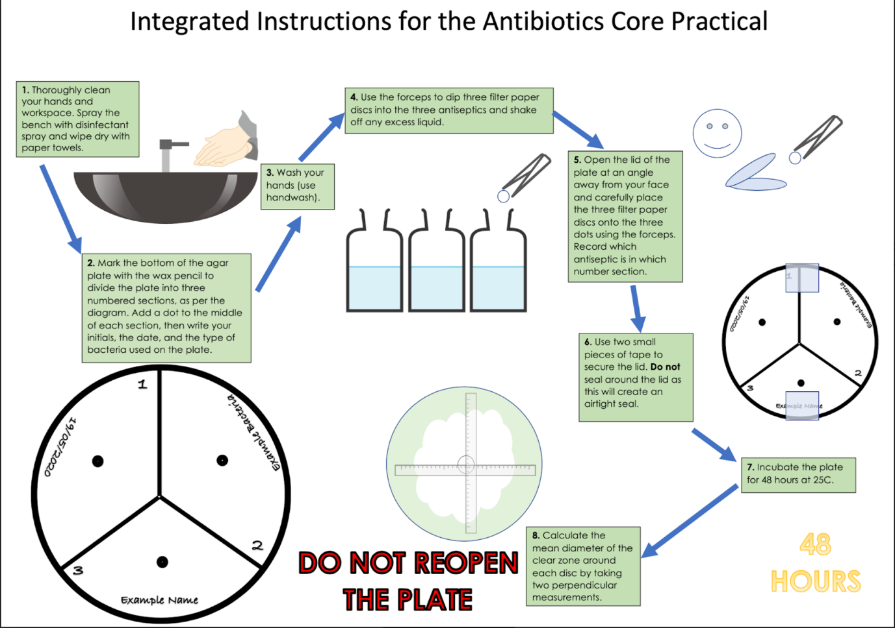Securing the petri dish with tape

Calculate the number of bacteria that would be present at the end of each scenario, assuming each started with 1 bacterium. You can write your answer out or write it in standard form.

1. Bacteria B with mean division time of 15 minutes, left for 8 hours.
2. Bacteria C with mean division time of 20 minutes, left for 2 hours.
3. Bacteria D with mean division time of 30 minutes, left for 6 hours.
4. Bacteria E with mean division time of 12 minutes, left for 3 hours.

1. Which best explains the purpose of this investigation?

Exit Ticket

A. To look at how best to make bacteria grow to spread disease.

B. To ensure no bacteria is allowed to grow.

C. To determine the most effective antibiotic/antiseptic.

2. Which is a feature of the aseptic technique?

A. Ensuring there are no nutrients in the agar medium.

B. Ensuring there is no contamination in the agar medium.

C. Ensuring that oxygen is not allowed into the agar medium.

3. Why is the plate incubated at 25 ºC?

A. To kill all bacteria

B. To minimise the risk of dangerous microorganisms from growing

C. Bacteria will not grow at lower temperatures

For question 3, read the guidance below and carry out the ‘fix-it’ task which has been set for you.

If you answered A

Bacterial cultures can be grown to test the effectiveness of antibiotics, but this involves allowing some bacteria to grow, in order to compare the growth with and without the antibiotic. This means that not all bacteria should be killed, but the temperature should be  
25 ºC to minimise the risk of dangerous microorganisms from growing.

*Describe the relationship between effectiveness of an antibiotic and size of clear zone.*

If you answered B

Bacterial cultures can be grown to test the effectiveness of antibiotics, but this involves allowing some bacteria to grow, in order to compare the growth with and without the antibiotic. This means that not all bacteria should be killed, but the temperature should be  
25 ºC to minimise the risk of dangerous microorganisms from growing.

*Describe the relationship between effectiveness of an antibiotic and size of clear zone.*

If you answered C

Bacterial cultures can be grown to test the effectiveness of antibiotics, but this involves allowing some bacteria to grow, in order to compare the growth with and without the antibiotic. This means that not all bacteria should be killed, but the temperature should be  
25 ºC to minimise the risk of dangerous microorganisms from growing. Bacteria will grow in lower temperatures but many are not able to grow in higher temperatures.

*Describe the relationship between effectiveness of an antibiotic and size of clear zone.*

Do Now:**

New Learning

Microscopes

1. State the function of a microscope.

________________________________________________________________________

1. Describe the key steps involved in the aseptic technique.

________________________________________________________________________

1. Explain why inoculated petri dishes are secured with tape but not the whole way around.

________________________________________________________________________

1. Describe how to calculate the total magnification of a microscope.

________________________________________________________________________

1. Name the part of the microscope where the slide is placed.

________________________________________________________________________

**Foundation:** Name the part of the microscope that is first used to bring the specimen into view.

________________________________________________________________________

**Stretch:** Explain why scientists are worried about antibiotic resistance.

________________________________________________________________________

________________________________________________________________________

Microscope techniques have developed over time, having originated from a simple magnifying glass. In the 1590s a Dutch father and son called Hans and Zacharias Jansen experimented with different lenses and made the first compound microscope.

The first real microscope was made and used by Anton van Leeuwenhoek in the 17th century – he was able to use the microscope to see very small objects, including **microscopic animals** and **bacteria**. His work was crucial to the development of **cell theory**. Microscopes that we use in school laboratories are light microscopes, which can be very useful for showing general structure of cells and other very small objects.

However, light microscopes are limited in how much detail they can provide (think about slides you may have prepared – were you able to see all the organelles?).

**Electron microscopes** have greater magnification and resolution than light microscopes and have allowed scientists to study cells in greater detail, furthering understanding of sub-cellular structures (things within the cell, e.g. organelles).

It is important to know the magnification we are using when looking at objects so that we get an idea of their actual size. Magnification can also be calculated by comparing the size of the image with the size of the real object if we know these two quantities.

The image on the right shows an electron micrograph image of a bacteriophage. The length of the scale bar is 1 cm (10 mm).

We can calculate the magnification used for this image:

**Magnification = Size of Image  
 Size of object**

                            = 10 mm  
                                0.0001 mm (nm converted to mm)

                            = 100000

(This object has been magnified 100000 times)

*Note: there are no units for magnification because it is just a ratio of how many times the object has been magnified.*



Activities

and Practice

1. Determine whether each statement is true or false:
2. Electron microscopes can provide a higher magnification than light microscopes.
3. The electron microscope was developed before the light microscope.
4. Much of the understanding of sub-cellular structures has come from the use of electron microscopes.
5. Total magnification of a light microscope can be calculated by adding together the eyepiece lens magnification and the objective lens magnification.
6. State the equation to calculate magnification using an image and its actual size.
7. Explain why electron microscopes are particularly useful.

________________________________________________________________________

________________________________________________________________________

1. Use the magnification equation to help you complete the missing values in the table. Show all working and units where necessary.

|  |  |  |
| --- | --- | --- |
| Size of Image | Size of Object | Magnification |
| 10 mm | 0.001 mm |  |
| 20 mm |  | 5000 |
|  | 5 µm | 10000 |
| 15 mm | 0.03 mm |  |
| 0.5 cm |  | 2500 |
|  | 0.035 mm | 1000 |

1. 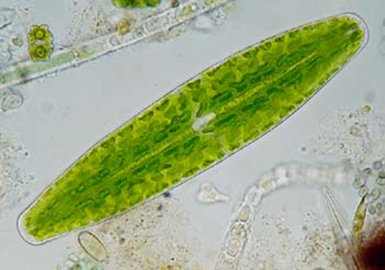The image below shows a chloroplast which has a length of 50 µm.
   * 1. Is 50 µm the image size or actual object size?
     2. Use a ruler to measure the length of the bar in the image.
     3. Use your measurement to calculate the magnification used to produce this image.
2. 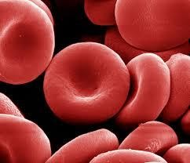The image below shows a selection of red blood cells.

Measure the length of the diameter of one of the red blood cells in the image. This image was obtained at a magnification of 5000.

Use this information to calculate the actual diameter of this red blood cell.

1. Ova (egg cells, sing. ovum) have an approximate length of 0.1 mm.  
   How big should an image of an ovum appear if it has been magnified  
   100 times?

1. Which statement is correct?

Exit Ticket

A. Both light microscopes and electron microscopes allow us to look at large objects that are far away on a much smaller scale.

B. Light microscopes have the greatest magnification and allow us to look at sub-cellular structures

C. Electron microscopes have greater magnification than light microscopes and have enhanced understanding of sub-cellular structures.

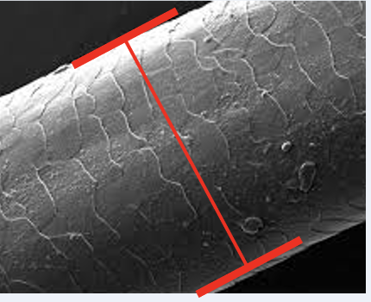

2. The image on the right shows a strand of human hair. The diameter bar measures 20 mm and the width of the hair is 0.001 mm. Which statement is correct?

A. Image size is 20 mm, actual size of object is 0.001 mm.

B. Image size is 0.001 mm, actual size of object is 20 mm.

C. Magnification is 20 times, actual size of object is 0.001 mm.

3. What is the magnification of this image using the given information?

A. 20000 mm

B. 20000

C. 0.00005

For question 3, read the guidance below and carry out the ‘fix-it’ task which has been set for you.

If you answered A

Magnification is calculated by dividing the size of the image by the actual size of the object and does not have a unit because it is a ratio of how many times we have ‘zoomed in’.

*Calculate the magnification of a skin cell where the size of the image is 40 mm and the actual size of the object is 0.002 mm.*

If you answered B

Magnification is calculated by dividing the size of the image by the actual size of the object and does not have a unit because it is a ratio of how many times we have ‘zoomed in’.

*Explain why it is useful for scientists to state the magnification they have used to produce images.*

If you answered C

Magnification is calculated by dividing the size of the **image** by the actual size of the **object** and does not have a unit because it is a ratio of how many times we have ‘zoomed in’.

*Calculate the magnification of a skin cell where the size of the image is 40 mm and the actual size of the object is 0.002 mm.*

Do Now:

New Learning

Observing Cells

1. State the equation to calculate the magnification of an image.

________________________________________________________________________

1. Explain why electron microscopes are useful.

________________________________________________________________________

1. Name the part of the microscope where the magnification is adjusted.

________________________________________________________________________

1. Describe the similarities and differences between plant and animal cells.

________________________________________________________________________

1. Name a type of plant cell that you would not expect to see many chloroplasts in.

________________________________________________________________________

**Foundation:** Name the organelle that is the site of photosynthesis.

________________________________________________________________________

**Stretch:** Describe some specialised cells and explain how their structure makes them well suited to their function.

________________________________________________________________________

________________________________________________________________________

Light microscopes are very useful to look at the overall structure and size of cells, which is very useful for comparing the size of eukaryotic and prokaryotic cells.

Electron microscopes are much more expensive but have much greater resolution, allowing scientists to look at organelles within the cells, and even structures within the organelles. Electron microscopes can cost up to £1 million so are only found in Universities and laboratories rather than schools.

Microscopic images must always show the magnification so they can be compared with images from other scientists. This is an international method used to standardise findings. You should have used microscopes in science already so the focus of this activity will be to calculate the actual size of the cells you are looking at, using the known magnification and measuring the size of the image.



Activities

and Practice

Choose the correct answer for each question:

1. Which is the correct equation to calculate magnification?
2. *Magnification = Size of Image/Size of Real Object*
3. *Magnification = Size of Real Object/Size of Image*
4. *Magnification = Size of Image x Size of Real Object*
5. Which is the correct first step in focusing an image using a light microscope?
   1. *Ensure the objective lens is on the highest power of magnification*
   2. *Ensure the objective lens is touching the slide*
6. *Ensure the objective lens is on the lowest power of magnification*
7. Which is best for looking at detail of sub-cellular structures?
8. *A magnifying glass*
9. *An electron microscope*
10. *A light microscope*

State the aim of this experiment:

______________________________________________________________________________

______________________________________________________________________________

Apparatus:

* Small piece of onion
* Scalpel
* White tile
* Forceps
* Microscope coverslip
* Microscope
* Iodine solution
* Pipette

Method:

1. Peel a thin layer of tissue from the inner surface of the onion.
2. Use forceps to carefully lay this thin layer of tissue on the microscope slide.
3. Use the pipette to add a drop of iodine solution on top of the onion sample.
4. Carefully lay a coverslip on the slide, placing one edge down first and lowering the other side slowly.
5. Ensure any excess liquid is soaked up carefully using filter paper or paper towel.
6. Place the slide on the stage of the microscope and secure with the stage clips.
7. Ensure the objective lens is set to the lowest magnification.
8. Look through the eyepiece and use the coarse focus wheel to bring the stage almost up to the objective lens, but do not let them touch.
9. Turn the coarse focus wheel in the other direction, increasing the distance between the stage and the objective lens, until the cells are more in focus.
10. Rotate the objective lens to the next power of magnification.
11. Turn the fine focus wheel to bring the cells into focus and look at the cells.
12. Rotate the objective lens to the highest power of magnification and use the fine focus wheel to ensure they are in focus.
13. In the results space below draw a clear labelled drawing of the cells that are visible. You should include labels for any organelles that are visible.
14. Use an eyepiece graticule to measure the length of one of the cells under your microscope, including units.
15. Measure the length of the same cell in your drawing, including units.
16. Use the equation to calculate the magnification of the drawing and write this underneath your drawing.

Results (including calculations):

Questions:

1. Why is it important to use a thin layer of onion cells?

________________________________________________________________________

________________________________________________________________________

________________________________________________________________________

________________________________________________________________________

1. Why is iodine solution added to the sample?

________________________________________________________________________

________________________________________________________________________

________________________________________________________________________

________________________________________________________________________

1. Why is the cover slip applied slowly and starting at one side?

________________________________________________________________________

________________________________________________________________________

________________________________________________________________________

________________________________________________________________________

1. Which statement is correct?

Exit Ticket

A. Light microscopes are able to show cell organelles in great detail

B. Light microscopes are useful for looking at relative sizes of cells

C. Light microscopes are useful for discovering new cell structures

2. Which is a precaution for looking at slides under a light microscope?

A. Ensure that there is no stain on the slide so it does not obstruct the sample

B. Ensure that the cover slip is carried and applied from the middle

C. Ensure that the sample of cells is a very thin layer

3. Which states the correct functions of the focusing wheels?

A. The fine focusing wheel is used to get the cells into the frame and the coarse focusing wheel is used to focus closely

B. The coarse focusing wheel is used to get the slide into the right position and the fine focusing wheel is used to get the cells into the frame

C. The coarse focusing wheel is used to get the cells into the frame and the fine focusing wheel is used to sharpen the image

For question 2, read the guidance below and carry out the ‘fix-it’ task which has been set for you.

If you answered A

A hazard is something that could cause harm during an experiment or investigation while a safety precaution is an action that is taken to protect against the hazard. Accuracy precautions are actions that are taken to ensure that the results collected are as accurate as possible. Stains are often necessary on slides so that cells or samples can be seen, such as iodine on plant cells.

*Explain why a thin layer of cells should be used to prepare a sample on a slide.*

If you answered B

A hazard is something that could cause harm during an experiment or investigation while a safety precaution is an action that is taken to protect against the hazard. Accuracy precautions are actions that are taken to ensure that the results collected are as accurate as possible. If a coverslip is carried and applied from the middle it is likely to get fingerprints on it, which could obstruct the view of cells under the microscope.

*Describe how a coverslip should be carried and applied to a slide.*

If you answered C

A hazard is something that could cause harm during an experiment or investigation while a safety precaution is an action that is taken to protect against the hazard. Accuracy precautions are actions that are taken to ensure that the results collected are as accurate as possible. A thin layer of cells is used when preparing a sample so that cells are not overlapping, making them much easier to see under a microscope.

*Explain the difference between accuracy and safety precautions and suggest a safety precaution that should be taken when observing slides under a microscope.*

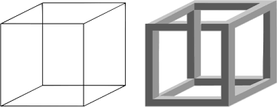Do Now:

New Learning

Diffusion

1. Describe the process of gas exchange in the lungs.

_______________________________________________________

1. Describe the movement of particles in liquids and gases.

2 cm

________________________________________________________________________

1. Explain why a stain is added to a specimen on a microscope slide.

________________________________________________________________________

1. Calculate the volume of the cube above.

________________________________________________________________________

1. Calculate the surface area of the same cube.

________________________________________________________________________

**Foundation:** Draw particle diagrams to show the arrangement of particles in a solid, a liquid and a gas.

**Stretch:** A student investigated the effect of temperature on the rate of diffusion of a food colouring in water. Identify the independent and dependent variables and a suitable control variable.

________________________________________________________________________

________________________________________________________________________

Diffusion is the **spreading out of particles**, of liquid or gas, resulting **in net (overall) movement** from an area of **high** **concentration** to **low** **concentration**.

Diffusion can occur through a **semi/selectively permeable membrane**, such as a cell membrane. A selectively permeable membrane is a membrane that allows some substances, usually smaller ones, to pass through it but not others.

Diffusion is important for a number of processes, particularly within the human body. During gas exchange oxygen and carbon dioxide diffuse between the alveoli and the blood. Urea is a waste product that is made by cells and diffuses out of cells into the blood and is then transported to the kidneys and excreted from the body

The **rate of diffusion** can be increased by:

* An increase in **temperature** (think about the movement of the particles)
* An increase in the **concentration gradient** (the difference between the high and low concentration)
* An increase in **surface area**

**Surface area to volume ratio** can be calculated by dividing the surface area by the volume of a cell, an organ or organism

E.g. for the cube with sides of 2 cm we have already calculated surface area to be 24 cm2 and volume to be 8 cm3.

Compare that to this cube, which has sides of length 1 cm.

Ratio = Surface area  
 Volume

= (1 cm x 1 cm) x 6  
 1 cm x 1 cm x 1 cm

= 6   
 1

= 6

Ratio = Surface area  
       Volume

2 cm

= 24 cm2

     8 cm3



 = 3

1 cm

Surface area to volume ratio does not have units because it is a relative measure of how much surface area there is compared to the volume. The smaller cube has a **larger surface area to volume ratio**, which means diffusion would be able to happen faster. This is why substances can diffuse in and out of unicellular organisms so easily.



Activities

and Practice

1. Determine whether each statement is true or false:
2. Diffusion is the spreading out of solid, liquid and gas particles from an area of high concentration to an area of low concentration.
3. Rate of diffusion can be increased by increasing the temperature.
4. Surface area to volume ratio is calculated by dividing the volume by the surface area.
5. During the process of gas exchange oxygen diffuses into the bloodstream and carbon dioxide diffuses in to the bloodstream.
6. Diffusion can take place through a semi-permeable membrane.
7. State the definition of diffusion.

________________________________________________________________________

________________________________________________________________________

1. State the definition of a concentration gradient.

________________________________________________________________________

________________________________________________________________________

1. Determine if the rate of diffusion would be increased or decreased by making the following changes:
2. Decreasing the temperature ________________________
3. Increasing the temperature ________________________
4. Increasing the surface area ________________________
5. Decreasing the surface area ________________________
6. Increasing the concentration gradient ________________________
7. Decreasing the concentration gradient ________________________

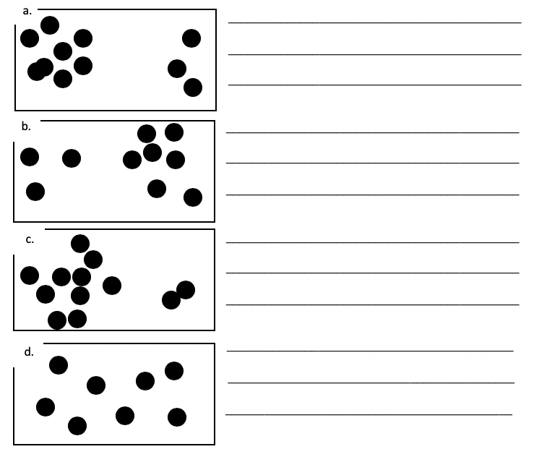5. On each of the diagrams below draw an arrow to indicate the direction of **net movement** of particles. Explain your answer using the terms **high concentration** and **low concentration.**

1. Which of the above diagrams would have the fastest rate of diffusion and which would have the slowest? Explain your answer.

_____________________________________________________________________

_____________________________________________________________________

1. 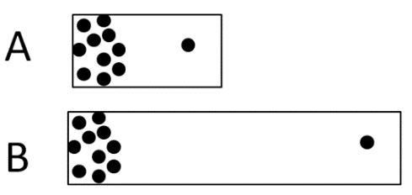Which of these would have a faster rate of diffusion? Explain your answer.

A  
  
B

________________________________________________________________________

________________________________________________________________________

1. Using your knowledge of particle theory explain why the rate of diffusion would be increased by increasing the temperature.

________________________________________________________________________

________________________________________________________________________

________________________________________________________________________

1. Using your knowledge of particle theory explain why diffusion cannot happen in solids.

________________________________________________________________________

________________________________________________________________________

________________________________________________________________________

1. Root hair cells are more effective at absorbing water than other types of plant cell. Explain why this is, using your knowledge of the structure of plant cells and root hair cells.

________________________________________________________________________

________________________________________________________________________

________________________________________________________________________

Stretch activity:

A scientist is trying to set a world record for the fastest rate of diffusion. Describe **all** the conditions that would be needed to allow this to happen.

1. Which is the best definition for diffusion?

Exit Ticket

A. Spreading out of liquid or gas particles resulting in net movement from high concentration to low concentration.

B. Spreading out of particles resulting in net movement from concentration to low concentration.

C. Bits of liquid or gas moving around to make the concentration the same everywhere

2. Which of these changes would not increase the rate of diffusion?

A. Increasing temperature

B. Increasing surface area

C. Decreasing concentration gradient

3. Which of these correctly states a stage in the process of gas exchange?

A. Oxygen diffuses from the alveoli into the bloodstream.

B. Carbon dioxide diffuses from the alveoli into the bloodstream.

C. Urea diffuses from the bloodstream into cells.

For question 2, read the guidance below and carry out the ‘fix-it’ task which has been set for you.

If you answered A

Diffusion is the movement of particles from a high concentration to a low concentration and is affected by a number of factors. Increasing temperature would increase the rate of diffusion because the particles would have more energy and be moving faster, therefore spreading out faster.

*Explain what is meant by a concentration gradient and how it affects the rate of diffusion.*

If you answered B

Diffusion is the movement of particles from a high concentration to a low concentration and is affected by a number of factors. Increasing surface area would increase the rate of diffusion because there is a greater area over which diffusion can occur rather than a small section.

*Explain what is meant by surface area and why increasing the surface area increases the rate of diffusion.*

If you answered C

Diffusion is the movement of particles from a high concentration to a low concentration and is affected by a number of factors. Decreasing the concentration gradient decreases the rate of diffusion because it means there is a smaller difference between the concentrations, meaning that movement of particles will not be as quick.

*Describe how concentration gradients are maintained in the body to maximise the rate of diffusion.*

Do Now:

New Learning

Diffusion in Living Things

1. Define diffusion.

________________________________________________________________________

1. State the factors that increase the rate of diffusion.

________________________________________________________________________

________________________________________________________________________

1. What is a concentration gradient?

________________________________________________________________________

1. Explain how the structure of root hair cells helps them carry out their function.

________________________________________________________________________

1. Explain why diffusion could not occur in a solid.

________________________________________________________________________

**Foundation:** Name the cellular process that releases energy.

________________________________________________________________________

**Stretch:** Explain why diffusion is a critical process for human survival.

________________________________________________________________________

________________________________________________________________________

Unicellular organisms have a relatively **high surface area to volume ratio**, which allows efficient diffusion of required substances.

Large multicellular organisms generally have a lower surface area to volume ratio but many have **adaptations** that increase their surface area to allow more efficient diffusion, including:

* 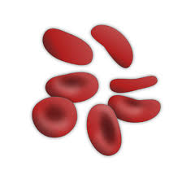Cell membranes are often very **thin**, creating a very **short path for diffusion**
* **Red blood cells** (pictured) have a biconcave disc shape to give them a greater surface area

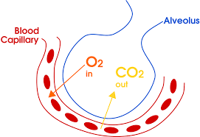

* Alveoli (pictured) are sphere shaped with a large surface area, and are only one epithelial cell thick
* 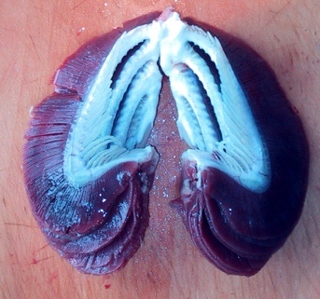**Gills** in fish (pictured) are also structured to have a large surface area

Alveoli and gills both have an **efficient blood supply**, which helps to maintain a **large concentration gradient** as substances are carried away quickly. If substances were not carried away quickly, diffusion would not be as efficient because there would not be a large concentration gradient.



Activities

and Practice

1. The image shows a close up of alveoli with their blood supply.
   1. A picture containing shape

      Description automatically generatedDescribe how the alveoli are adapted to allow efficient diffusion.

_____________________________________

_____________________________________

_____________________________________

_____________________________________

_____________________________________

* 1. Explain why efficient diffusion is important to the function of the alveolus.

_____________________________________________________________________

_____________________________________________________________________

_____________________________________________________________________

1. The image shows a close up of a synapse.
   1. Shape, icon

      Description automatically generatedDescribe how this synapse is adapted to allow efficient diffusion.

__________________________________________________

__________________________________________________

__________________________________________________

__________________________________________________

__________________________________________________

* 1. Explain why efficient diffusion is important to the function of the synapse.

_____________________________________________________________________

_____________________________________________________________________

_____________________________________________________________________

1. The image shows a close up of villi in the small intestine.
   1. Diagram

      Description automatically generatedDescribe how these villi are adapted to allow efficient diffusion.

______________________________________________

______________________________________________

______________________________________________

* 1. Explain why efficient diffusion is important to the function of the villi.

_____________________________________________________________________

_____________________________________________________________________

_____________________________________________________________________

1. The image below shows a placenta. Describe how it is adapted to allow efficient diffusion.

________________________________________________________________________

________________________________________________________________________

________________________________________________________________________

Stretch activity:

Diffusion of glucose from the small intestine into the bloodstream is not always possible. Discuss when and would this not be possible.

1. Which describes an example of diffusion?

Exit Ticket

A. Oxygen molecules moving from an area of low concentration in the bloodstream to an area of high concentration in the cells

B. Glucose molecules moving from an area of high concentration in the small intestine to an area of lower concentration in the bloodstream

C. Gills taking in water molecules to allow respiration in fish

2. Which would be useful adaptations to increase the rate of diffusion?

A. A long path for diffusion and thick blood vessels

B. A short path for diffusion and thick blood vessels

C. A short path for diffusion and an efficient blood supply

3. Unicellular organisms generally allow efficient diffusion because…

A. They are very small so don’t need many molecules to have a high concentration

B. They have a relatively large surface area compared to their volume

C. They have a relatively large volume compared to their surface area

For question 1, read the guidance below and carry out the ‘fix-it’ task which has been set for you.

If you answered A

Diffusion is the movement of substances from high concentration to low concentration. Oxygen molecules move from a high concentration in the bloodstream to an area of low concentration in cells, where they are used in aerobic respiration.

*State the definition for diffusion and describe two examples of diffusion in the body.*

If you answered B

Diffusion is the movement of substances from high concentration to low concentration. Oxygen molecules move from a high concentration in the small intestine to an area of low concentration in the bloodstream, where they are carried around the body to cells and used in aerobic respiration.

*The rate of diffusion of glucose from the small intestine to the bloodstream changes throughout the day. Suggest when it is at its highest and explain why.*

If you answered C

Diffusion is the movement of substances from high concentration to low concentration. Gills absorb oxygen through their large surface area, where oxygen molecules move from a high concentration dissolved in water to a low concentration in the gills. From here the oxygen molecules are transported around the body and used in aerobic respiration.

*State the word equation for aerobic respiration and explain why it is important for cells and organisms.*

Do Now:

New Learning

Osmosis

1. Draw and label a plant cell and an animal cell.

________________________________________________________________________

1. Name the organelles that are found in plant cells but not animal cells.

________________________________________________________________________

1. Describe the role of the vacuole in a plant cell.

________________________________________________________________________

1. State the word equation for photosynthesis.

________________________________________________________________________

1. Explain why photosynthesis is important for food chains.

________________________________________________________________________

**Foundation:** What would happen to a plant if it was never watered?

________________________________________________________________________

**Stretch:** Explain why water is an important molecule.

________________________________________________________________________

________________________________________________________________________

Osmosis is the **diffusion of water** from a **dilute** solution to a **concentrated** solution through a **partially permeable membrane.** A partially permeable membrane (e.g. a cell membrane) is a membrane that lets particular substances through it, either in or out.

*Note: Concentration is the number of particles in a given area. When we use the word* ***concentration*** *it refers to the concentration of the* ***solute*** *(the solid dissolved in the solution). A dilute solution has a low concentration of solute (e.g. sodium chloride) whereas a concentrated solution has a high concentration of solute.*

Osmosis is the movement of water molecules, moving from a dilute to a concentrated solution, which means that eventually there will be an equal concentration.

Osmosis causes different results in plant cells and animal cells because plant cells contain a **cell wall** which provides strength and support and a **permanent vacuole** which can store cell sap, whereas animal cells do not. This means animal cells are much more vulnerable to damage.

Here are a few new key terms:

A **hypertonic** solution is one in which the external solution has a higher concentration of solute than the cell (e.g. salt water)

A **hypotonic** solution is one in which the external solution has a lower concentration of solute than the cell (e.g. distilled water)

An **isotonic** solution is one in which the external solution has the same concentration of solute as the cell

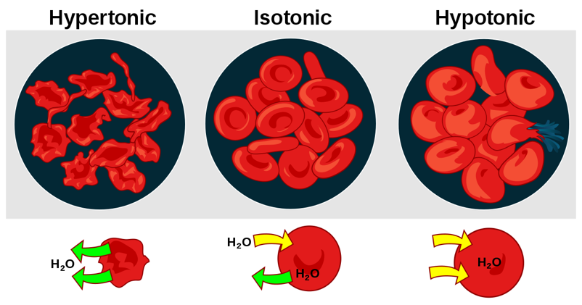What happens to **animal** cells?

When red blood cells are put into a **isotonic** solution there is no net change.

When red blood cells are put into a **hypotonic** solution, water moves from a dilute solution (outside the cell) to a concentrated solution (inside the cell), resulting in the cells overfilling and eventually **lysing** (bursting).

When red blood cells are put into a **hypertonic** solution, water moves from a dilute solution (inside the cell) to a concentrated solution (outside the cell), resulting in the cells becoming **shrivelled**.

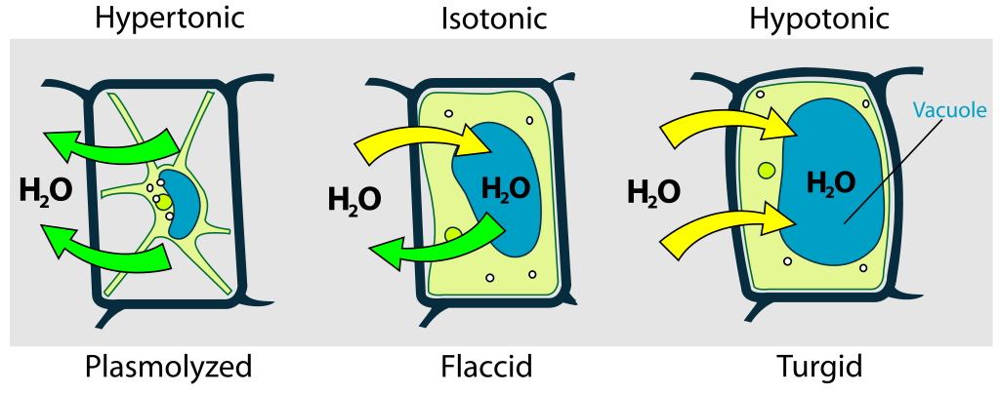What happens to **plant** cells?

When plant cells are put into a **hypotonic** solution, water moves from a dilute solution (outside the cell) to a concentrated solution (inside the cell), resulting in the vacuole filling up and pushing the cell membrane into the cell wall. This cell has become **turgid**.

When plant cells are put into a **isotonic** solution there is no net change. This cell is **flaccid.**

When plant cells are put into a **hypertonic** solution, water moves from a dilute solution (inside the cell) to a concentrated solution (outside the cell), resulting in the vacuole becoming depleted and the cell membrane coming away from the cell wall. This cell has become **plasmolysed**.



Activities

and Practice

* + 1. Determine if the following statements are true or false:

1. Osmosis is the movement of water from a concentrated solution to a dilute solution.
2. A hypotonic solution is one that has a lower concentration than the cell/sample.
3. When a plant cell is placed in a hypotonic solution it becomes turgid
4. When an animal cell is placed in a hypertonic solution it becomes plasmolysed as the vacuole has shrunk
5. A partially permeable membrane is one that allows the passage of small molecules only

2. State the definition of osmosis:

________________________________________________________________________

________________________________________________________________________

________________________________________________________________________

3. State the definition of a partially permeable membrane:

________________________________________________________________________

________________________________________________________________________

________________________________________________________________________

4. State the definitions of:

a. **Hypertonic**

_____________________________________________________________________

_____________________________________________________________________

_____________________________________________________________________

* 1. **Hypotonic**

_____________________________________________________________________

_____________________________________________________________________

_____________________________________________________________________

* 1. **Isotonic**

_____________________________________________________________________

_____________________________________________________________________

_____________________________________________________________________

1. For each scenario label each side as hypotonic, hypertonic or isotonic and draw an arrow to show the net movement of water. The small dots represent water molecules and the larger dots represent sugar (the solute)

|  |  |  |  |  |
| --- | --- | --- | --- | --- |
| **a.** |  |  | **b.** |  |
| **c.** |  |  | **d.** |  |

6. Write a method you could use to determine the concentration inside a piece of fruit.

________________________________________________________________________

________________________________________________________________________

________________________________________________________________________

________________________________________________________________________

________________________________________________________________________

________________________________________________________________________

________________________________________________________________________

________________________________________________________________________

________________________________________________________________________

Stretch Activity

Often pupils will leave exam revision to the last minute and then stare blankly at their notes, hoping they will absorb the information by osmosis. Explain why this cannot happen.

1. Which best states the definition of osmosis?

Exit Ticket

A. Water going out of cells into salty water.

B. The diffusion of water molecules from a dilute solution to a concentrated solution.

C. The movement of molecules from a high concentration to a low concentration

2. Which scenario would result in a turgid cell?

A. A plant cell being placed in a hypotonic solution

B. An animal cell being placed in a hypertonic solution

C. A plant cell being placed in a hypertonic solution

3. A hypotonic solution is…

A. A solution that has a higher concentration than the cell/sample

B. A solution that has the same concentration as the cell

C. A solution that has a lower concentration than the cell/sample

For question 2, read the guidance below and carry out the ‘fix-it’ task which has been set for you.

If you answered A

A turgid cell is formed when a plant cell gains water. This happens when plant cells are put into a hypotonic solution, water moves from a dilute solution (outside the cell) to a concentrated solution (inside the cell), resulting in the vacuole filling up and pushing the cell membrane into the cell wall.

*Explain why animal cells cannot become plasmolysed.*

If you answered B

A turgid cell is formed when a plant cell gains water. This happens when plant cells are put into a hypotonic solution, water moves from a dilute solution (outside the cell) to a concentrated solution (inside the cell), resulting in the vacuole filling up and pushing the cell membrane into the cell wall.

*Describe what happens to animal cells when they are placed in a hypertonic solution.*

If you answered C

A turgid cell is formed when a plant cell gains water. This happens when plant cells are put into a hypotonic solution, water moves from a dilute solution (outside the cell) to a concentrated solution (inside the cell), resulting in the vacuole filling up and pushing the cell membrane into the cell wall.

*Explain why animal cells cannot become plasmolysed.*

*Explain what is meant by a hypotonic solution and describe what would happen if a plant cell was placed in a hypotonic solution.*

Do Now:

New Learning

Osmosis Investigation

1. Define osmosis.

________________________________________________________________________

1. Name the type of membrane required for osmosis to take place.

________________________________________________________________________

1. Describe the difference between a hypertonic solution and a hypotonic solution.

________________________________________________________________________

1. State the SI unit of mass.

________________________________________________________________________

1. Describe the difference between mass and weight.

________________________________________________________________________

**Foundation:** What is an independent variable?

________________________________________________________________________

________________________________________________________________________

**Stretch:** A student investigates the effect of different salt water concentrations on the mass of a potato. Identify the independent and dependent variables.

________________________________________________________________________

________________________________________________________________________

We can use osmosis to look at relative concentrations of solutes within plant cells. We can look at what happens to them and measure their change in mass to determine their concentration relative to the solution they are placed in.

Calculating percentage change in mass

If the final number is bigger than the initial number you are calculating a **percentage increase.**

Increase = Final number – Initial Number

e.g. Potato A had an initial mass of 5g and now has a mass of 7.5 g

Increase = 7.5 g – 5 g

                = 2.5 g

% Increase = 2.5    x 100  
                         5

                    = 50% increase

% Increase =  Increase       x 100

                     Initial number

If the final number is smaller than the initial number you are calculating a **percentage decrease.**

e.g. Potato B had an initial mass of 5 g and now has a mass of 4.5 g

Decrease  = 5 g – 4.5 g

                   = 0.5 g

% Decrease = 0.5    x 100  
                           5

                    = 10% decrease

Decrease  = Initial number – Final number

% Decrease = Decrease     x 100

                      Initial number



Activities

and Practice

Determine if each statement is true or false:

1. Osmosis involves a fully permeable membrane
2. Osmosis is movement of water from a dilute concentration to a concentrated solution
3. An independent variable is one which is kept the same during an experiment
4. A dependent variable is one which is measured during an experiment (on the y-axis)
5. To make an experiment fair it is important to change as many variables as possible

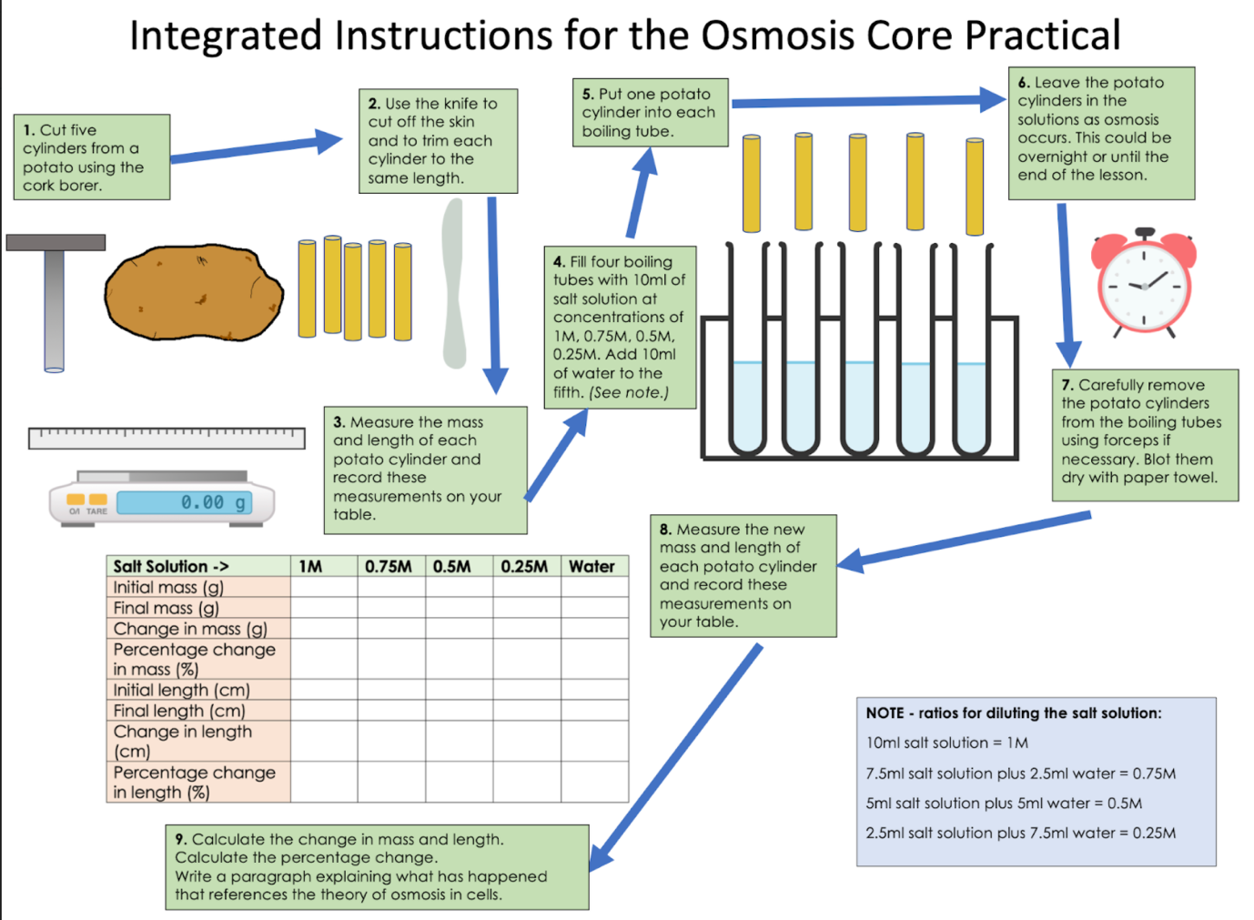

1. What was the independent variable in this experiment?

Exit Ticket

A. Mass of potato cylinder

B. Concentration of sugar solution

C. Change in mass of potato cylinder

2. What would you expect to happen if a piece of onion was left in a hypertonic solution?

A. The onion would disappear as the cells would lyse

B. The onion would decrease in mass.

C. The onion would increase in mass.

3. What would you expect to happen if a sample of animal cells were left in a hypotonic solution?

A. They would expand and become turgid

B. They would expand and burst

C. They would become shrivelled

For question 2, read the guidance below and carry out the ‘fix-it’ task which has been set for you.

If you answered A

A hypertonic solution is an external solution that is more concentrated that the solution within the cell. If a piece of onion was left in a hypertonic solution water would move from a dilute solution to a concentrated solution, meaning water would leave the onion cells. This would result in the cells becoming plasmolysed and the mass decreasing. The onion could not disappear as it is a plant cell so it has a cell wall for structure and support – lysis can only happen to animal cells as they do not have a cell wall.

*Describe what would happen to a plant cell and an animal cell if they were both placed in a hypertonic solution.*

If you answered B

A hypertonic solution is an external solution that is more concentrated that the solution within the cell. If a piece of onion was left in a hypertonic solution water would move from a dilute solution to a concentrated solution, meaning water would leave the onion cells. This would result in the cells becoming plasmolysed and the mass decreasing.

*Suggest what would happen to the mass of onion if it was placed in a hypotonic solution and explain why this could not happen to a sample of animal cells.*

If you answered C

A hypertonic solution is an external solution that is more concentrated that the solution within the cell. If a piece of onion was left in a hypertonic solution water would move from a dilute solution to a concentrated solution, meaning water would leave the onion cells. This would result in the cells becoming plasmolysed and the mass decreasing.

*Explain the difference between hypertonic and hypotonic solutions and describe what happens if a plant cell is placed in either.*

Do Now:

New Learning

Active Transport

1. Define diffusion.

________________________________________________________________________

1. Explain what is meant by a concentration gradient.

________________________________________________________________________

1. Describe what happens to a plant cell when placed in a hypertonic solution.

________________________________________________________________________

1. Describe where cells get energy.

________________________________________________________________________

1. Explain what organisms need energy for.

________________________________________________________________________

**Foundation:** State the factors that increase the rate of diffusion.

________________________________________________________________________

________________________________________________________________________

**Stretch:** A student says that plants only produce oxygen and pass it on to other species. Are they correct? Why?

________________________________________________________________________

________________________________________________________________________

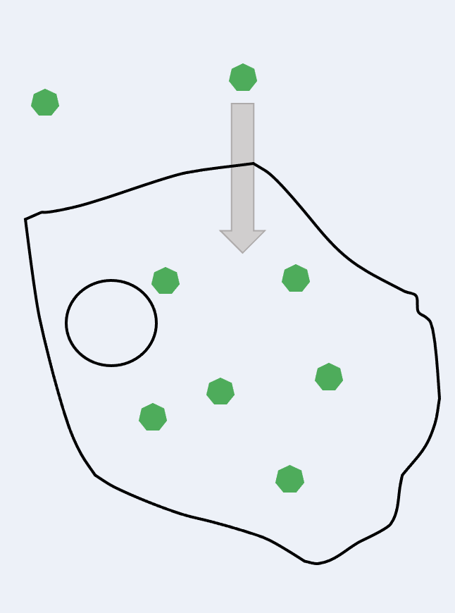Active transport works **against the concentration gradient**, unlike diffusion which is a passive process as it does not require energy and works down a concentration gradient.

**Active transport** is the movement of substances from a more **dilute** solution to a more **concentrated** solution, **requiring energy** from respiration.

Diffusion and active transport are both used in the **small intestine** to transport glucose into the bloodstream so it can be taken to cells for respiration. Active transport is used when the concentration of glucose in the small intestine is **lower** than the concentration of glucose in the blood, for example several hours after a meal when the food has been almost fully digested and diffused into the bloodstream already.

Active transport is also used in **root hair cells** to absorb **mineral ions** from the soil that are essential for plant growth. This is because there is a higher concentration of these ions in the root hair cells, but they need more so continue to absorb ions by active transport. Root hair cells also absorb water but this does not use active transport as there is generally a higher concentration of water in the soil (outside the cell) than within it.

Choose the correct answer for each question:

Activities

and Practice

1. Active transport occurs when…

1. Molecules move in the direction of the concentration gradient
2. Molecules move in the opposite direction of the concentration gradient
3. There is no concentration gradient

2. Active transport is required in the small intestine when…

1. The concentration of glucose is higher in the bloodstream than the small intestine
2. The concentration of glucose is higher in the small intestine than the bloodstream
3. The concentration of oxygen is higher in the small intestine than the bloodstream

3. Which best explains the difference between diffusion and active transport?

1. Active transport requires energy from respiration but diffusion does not
2. Active transport occurs in the direction of the concentration gradient but diffusion does not
3. Active transport is the movement of water molecules, diffusion is the movement of all solute molecules

Extended Response

The diagram shows a simple sodium-potassium pump. Sodium-potassium pumps are specialised transport proteins found in cell membranes and are crucial to a number of processes in the body, including the transmission of nerve impulses, heart contractions and kidney functions. The pump allows the concentrations of sodium and potassium to remain relatively constant.

1. **Use the diagram to determine if the pump works by diffusion or active transport. Your answer should include as much evidence as possible.**
2. **Explain the possible consequences of this pump malfunctioning**

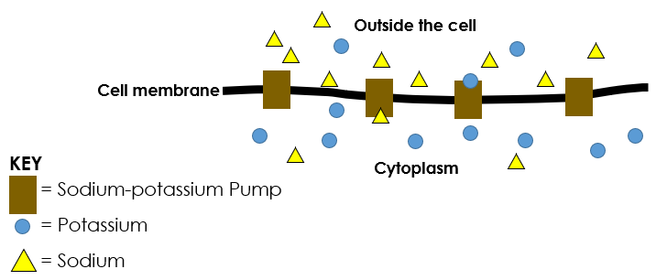

________________________________________________________________________

________________________________________________________________________

________________________________________________________________________

________________________________________________________________________

________________________________________________________________________

________________________________________________________________________

________________________________________________________________________

________________________________________________________________________

________________________________________________________________________

________________________________________________________________________

________________________________________________________________________

________________________________________________________________________

________________________________________________________________________

________________________________________________________________________

________________________________________________________________________

________________________________________________________________________

1. Active transport is…

Exit Ticket

A. When molecules go the wrong way round and need energy to give them a push

B. When molecules go from low to high concentration, releasing energy

C. The movement of molecules from low to high concentration, requiring energy

2. When would active transport take place?

A. When a person has eaten recently and has lots of glucose in their gut

B. When a plant takes in important minerals for growth through the soil

C. When a plant takes in water for photosynthesis

3. Diffusion does not require energy because…

A. Molecules are travelling in the same direction as the concentration gradient

B. Molecules are travelling in the opposite direction to the concentration gradient

C. It is more important that the cell keeps the energy to use in respiration

For question 2, read the guidance below and carry out the ‘fix-it’ task which has been set for you.

If you answered A

Active transport is the movement of substance against a concentration gradient, from low concentration to high concentration and requiring energy. If a person had eaten recently and had lots of glucose in their gut there would be a high concentration of glucose in the gut and a lower concentration in the bloodstream, so in this case diffusion would take place.

*Describe the similarities and differences between diffusion and active transport.*

If you answered B

Active transport is the movement of substance against a concentration gradient, from low concentration to high concentration and requiring energy. Plants take in minerals from the soil despite there being a lower concentration of mineral ions in the soil than in the roots, meaning this is an example of active transport.

*Diffusion and active transport are both used in the small intestine. Suggest when each would be used.*

If you answered C

Active transport is the movement of substance against a concentration gradient, from low concentration to high concentration and requiring energy. Generally there is a higher concentration of water in soil than there is in root hair cells, meaning that water moves from a high concentration to a low concentration, which is diffusion.

*Active transport takes place when root hair cells absorb mineral ions from the soil. Explain what this tells you about the concentrations of mineral ions in the soil and the root hair cells.*

Do Now:

New Learning

Cell Division

1. Arrange the following in size order: chromosomes, DNA, gene, nucleus.

________________________________________________________________________

1. Explain why new cells have to be made.

________________________________________________________________________

1. Explain the difference between unicellular and multicellular organisms.

________________________________________________________________________

1. State the location of genetic material in eukaryotic cells.

________________________________________________________________________

1. Many species of animals and plants have chromosomes in pairs. Explain why this is.

________________________________________________________________________

**Foundation:** Where is DNA found in prokaryotic cells?

________________________________________________________________________

**Stretch:** Why is it useful for a species to have variation in its population?

________________________________________________________________________

________________________________________________________________________

What is in the nucleus?

The nucleus consists of chromosomes and their genes which are made of a molecule called DNA.

A **gene** is a small section of DNA that controls a characteristic of your body (e.g. eye colour). Different versions of genes are called **alleles**.

These genes are grouped together on chromosomes and there may be thousands of genes on one chromosome.

Cells are constantly going through a cycle called the **cell** **cycle**. This cell cycle will last for varying amounts of time depending on the type of cell, most cell cycles in mammals last somewhere around 24 hours (when growing in vitro, which means in Petri dishes in the lab) whereas the cell cycle for yeast can be shorter than 2 hours! ​

There comes a time in the cell cycle where a cell will need to divide into two new identical cells. Cells need to divide for different reasons. Some organisms (such as bacteria) **reproduce** **asexually** by splitting into two new cells. In multicellular organisms, cells need to divide so that the organism can **grow** bigger and so that any cells or tissues in the organism that are damaged can be **repaired** by new cells. Some organs (such as the skin) constantly require new cells so rely on cell division. ​

Before a cell can divide into two new cells it needs to go through the ‘growth phase’ of the cell cycle. During this growth phase the number of organelles inside the cell double (or replicate). This includes the nucleus, as a new nucleus is needed for the new cell all of the DNA inside the cell must also be replicated.

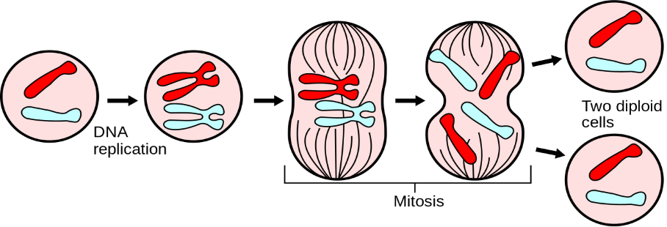If this did not happen then each time the cell divided there would be half the genetic material in the new generation compared to the previous generation. A species is a group of organisms that can breed to produce fertile offspring, so for the species to continue they need to have the same number of chromosomes in each generation.

You may often hear this process referred to as **mitosis**, but that is not the whole story. The whole process is cell division and mitosis is just one part of this, specifically the part that involves the division of the genetic material (DNA in chromosomes).

After the growth phase where DNA has been replicated the **chromosomes** are **pulled apart** to separate ends of the cell, ready for division.

The final part of the cell cycle is the splitting of the **cell membrane** to produce **two identical cells.** The offspring produced through mitotic cell division can be referred to as **diploid** which means they contain all 46 chromosomes, arranged in 23 **pairs**. You will learn later about meiosis, which is the making of gametes, and results in **haploid** cells being produced, which only have one chromosome from each pair (one from each parent).



Activities

and Practice

* + 1. Determine if the following statements are true or false:

1. Mitosis is used by multicellular organisms to reproduce asexually
2. During mitosis DNA is replicated
3. At the end of mitosis four identical cells are produced
4. Mitosis can be used for growth and repair
5. The cells produced at the end of mitosis have half the number of chromosomes as the original cell

2. Describe how cell division is used in:

a. Unicellular organisms

_____________________________________________________________________

_____________________________________________________________________

* 1. Multicellular organisms

_____________________________________________________________________

_____________________________________________________________________

1. 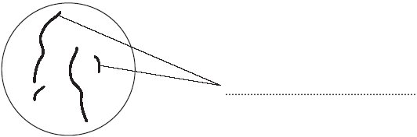**Diagram 1** shows the nucleus of a body cell as it begins to divide by mitosis.

Diagram 1

* 1. Use a word from the box to label **Diagram 1**.

**alleles             chromosomes             gametes**

* 1. Complete **Diagram 2** to show what the nucleus of one of the cells produced by this mitosis would look like.

Diagram 2

1. Order the following statements to show the order of events during cell division.
2. Two new identical daughter cells are produced
3. The cytoplasm and cell membrane divides
4. The chromosomes are pulled apart to separate ends of the cell
5. The cell grows and doubles its sub-cellular structures and replicates its DNA
6. The chromosomes line up along the centre of the cell before being pulled by spindle fibres

Order:

________ 🡪 ________ 🡪 ________ 🡪 ________ 🡪 ________

1. Explain why the DNA and sub-cellular structures must be replicated before the cell divides.

________________________________________________________________________

________________________________________________________________________

________________________________________________________________________

________________________________________________________________________

________________________________________________________________________

________________________________________________________________________

1. Explain why mitosis may happen more frequently in young organisms than mature ones.

________________________________________________________________________

________________________________________________________________________

________________________________________________________________________

________________________________________________________________________

________________________________________________________________________

________________________________________________________________________

1. Mitosis is…

Exit Ticket

A. The process of making new cells

B. The process of division of genetic material to make two new cells

C. The process of cells replicating their DNA and sub-cellular structures

2. Which is a stage of cell division?

A. Replication of DNA and sub-cellular structures

B. One cell being replaced by a newer cell

C. A cell producing two new cells alongside it

3. Which best describes the cells that are produced at the end of mitosis?

A. Two daughter cells with half the number of chromosomes as the original cell

B. Two daughter cells with the same number of chromosomes as the original cell

C. One daughter cell with double the number of chromosomes as the original cell

For question 1, read the guidance below and carry out the ‘fix-it’ task which has been set for you.

If you answered A

Mitosis is part of the process of cell division, specifically the part where the genetic information (DNA arranged in chromosomes) is split up and two new cells are formed. The making of new cells is part of the cell division process but mitosis itself refers to the division of the genetic material.

*Explain why the genetic material is replicated before mitosis takes place.*

If you answered B

Mitosis is part of the process of cell division, specifically the part where the genetic information (DNA arranged in chromosomes) is split up and two new cells are formed. The making of new cells is cell division but mitosis refers to the separation of genetic material.

*Compare the cells that are produced after mitosis to the original cell and describe where this form of cell division is found.*

If you answered C

Mitosis is part of the process of cell division, specifically the part where the genetic information (DNA arranged in chromosomes) is split up and two new cells are formed. The DNA and sub-cellular structures must be replicated before mitosis takes place to ensure that each of the two new cells is identical to the original cell and has the correct amount of DNA/number of chromosomes.

*Briefly outline the process of cell division and highlight the section that is mitosis.*

Do Now:

New Learning

Cancer

1. State 2 uses of cell division.

________________________________________________________________________

1. Define mitosis.

________________________________________________________________________

1. Describe what happens to the genetic material before cell division takes place.

________________________________________________________________________

1. Explain what is meant by a balanced diet.

________________________________________________________________________

1. Describe how to test for the presence of protein.

________________________________________________________________________

**Foundation:** Give an example of a unicellular organism.

________________________________________________________________________

**Stretch:** A rise in veganism and vegetarianism has some dieticians worried that people are not getting a balanced diet. Explain why.

________________________________________________________________________

________________________________________________________________________

This can result in the formation of **tumours**, of which there are two different types:

Cancer is when **cell division** happens **uncontrollably,** so cell number increases inappropriately.

* 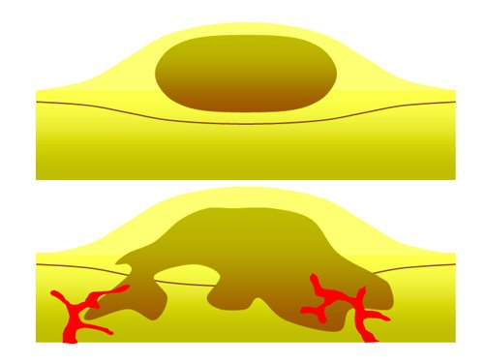**Benign** tumours are a mass of cells contained in **one** **area**
* **Malignant** tumours are formed of cancer cells that **invade** **other** **tissues** and spread around the body forming secondary tumours

There are various **lifestyle risks** for developing different types of cancer including:

* Poor diet
* Sedentary lifestyle (lack of exercise)
* Excessive alcohol or drug consumption
* Smoking
* UV exposure
* Exposure to various chemicals or radiation

There are also **genetic risks** for cancer such as the BRCA gene for breast and ovarian cancer. These risks do not mean a person will certainly get cancer but they increase the chance of it happening, which is why they are referred to as risk factors and not causes.



Activities

and Practice

**Choose the right option for each question.**

* + 1. Malignant tumours are more worrying than benign tumours because…

1. They can invade other tissues and create secondary tumours
2. They are contained in one area which increases the size of the tumour
   * 1. Cancer occurs when…
   1. Cell division happens uncontrollably so that the number of cells decreases excessively
   2. Cell division happens uncontrollably so the number of cells increases excessively
      1. A person could reduce their risk of cancer by…
3. Exercising more, eating a healthy balanced diet and limiting alcohol intake
4. Drinking more alcohol, smoking and sunbathing every day

Answer the following questions:

1. What causes cancer?​

________________________________________________________________________

1. What is a benign tumour?​

________________________________________________________________________

1. What is a malignant tumour?​

________________________________________________________________________

1. Which type of tumour leads to cancer?​

________________________________________________________________________

1. Name three risk factors for developing cancer.​

________________________________________________________________________

1. Cancer is…

Exit Ticket

A. The process of making new cells

B. A horrible infectious disease

C. Uncontrollable cell division

2. What is the difference between a benign and a malignant tumour?

A. Benign tumours are isolated in one area, malignant tumours are all over the body

B. Benign tumours are isolated in one area, malignant tumours have the potential to spread to form new tumours around the body

C. Benign tumours are all over the body, malignant tumours are isolated in one area

3. A risk factor is…

A. An unhealthy lifestyle choice that means a person will get cancer

B. A gene that is passed down and causes cancer

C. A gene or lifestyle choice that will can increase the likelihood of a person developing cancer

For question 2, read the guidance below and carry out the ‘fix-it’ task which has been set for you.

If you answered A

Benign tumours are thought of as being the ‘safe’ tumours because they are isolated in one area, whereas malignant tumours have the potential to spread to form secondary tumours in other parts of the body. This does not mean they always form tumours around the body, just that they have the potential to, whereas benign tumours do not.

*Suggest why a diagnosis of a benign tumour is preferable to a diagnosis of a malignant tumour.*

If you answered B

Benign tumours are thought of as being the ‘safe’ tumours because they are isolated in one area, whereas malignant tumours have the potential to spread to form secondary tumours in other parts of the body. This spreading around the body is where the different stages of cancer come in.

*Suggest why early identification of a malignant tumour is advantageous for cancer treatment.*

If you answered C

Benign tumours are thought of as being the ‘safe’ tumours because they are isolated in one area, whereas malignant tumours have the potential to spread to form secondary tumours in other parts of the body.

*Explain why benign tumours are thought of as ‘safer’ tumours.*

Do Now:

New Learning

Stem Cells

1. Explain what is meant by a risk factor.

________________________________________________________________________

1. State two lifestyle risk factors.

________________________________________________________________________

1. Give an example of a specialised cell.

________________________________________________________________________

1. Explain how red blood cells are specialised for their function.

________________________________________________________________________

1. Describe the differences between a plant cell and an animal cell.

________________________________________________________________________

**Foundation:** Give an example of a prokaryotic cell and a eukaryotic cell.

________________________________________________________________________

**Stretch:** Which type of microscope would be more useful to use to look at the features of different types of specialised cell? Explain why.

________________________________________________________________________

________________________________________________________________________

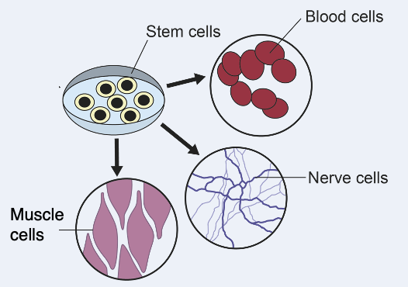Cells can become specialised cells by the process of **differentiation**. As cells **differentiate** into **specialised cells,** they acquire the specific structures needed for that cell type.

**Stem cells** are cells that are **capable of differentiating** into specific cell types.

Stem cells from **developing embryos** can differentiate into **all human cell types** to develop into a foetus. Most animals begin the differentiation phase at an early stage of development, and after this point the cells are already on a path to become a specific type of cell which cannot be changed.

**Embryonic stem cells** can be induced to produce a desired cell type as they have not been differentiated yet. Embryonic stem cells come from embryos at a very early stage of development and usually from IVF (*in vitro fertilisation)* embryos that are not going to be implanted into a uterus.

These embryonic stem cells are referred to as **pluripotent**, which means they are capable of differentiating into a number of different types of cell.

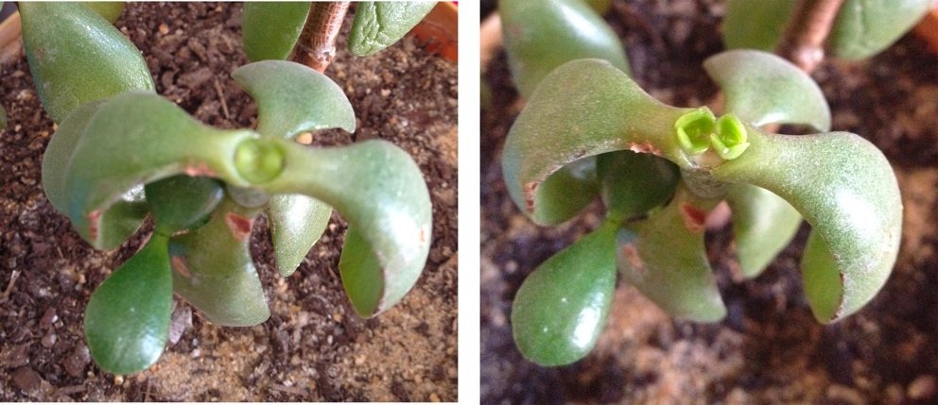**Adult bone marrow** contains stem cells that can differentiate into different types of **blood cell**, so they do not have as many possible uses as embryonic stem cells.

**Meristems** in plants contain stem cells that can differentiate into **all plant cells** to develop a new plant.

Most plants are able to differentiate cell types throughout their lives. Meristems can be used to **clone** plants that are at risk of extinction or for a particular crop plant that has a desired feature (such as disease resistance). Meristems are found in roots, where they help the plant to grow more roots, in shoots, where they help the plant to grow taller and wider, and between xylem and phloem (which you will learn more about later), allowing the plant to grow wider. These result in the annual growth rings you can see in trees.

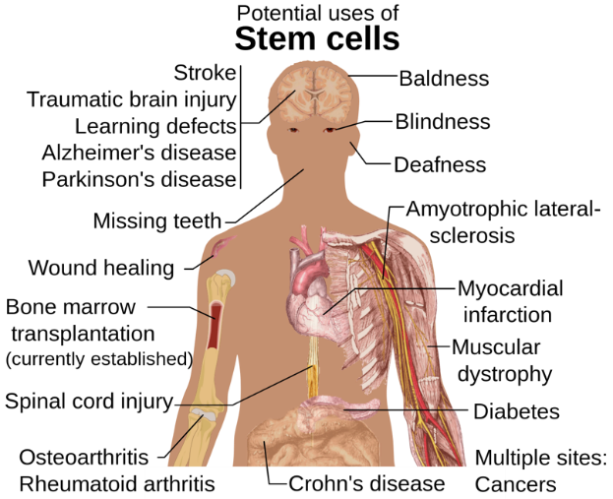Stem cell therapy is an increasingly useful research field for many human diseases. Patients suffering with **diabetes** or **paralysis** may be treated with stem cells to help grow back **insulin producing cells** or **motor neurons.**

**Therapeutic cloning** uses an embryo with the **same DNA** as the patient so that the cells grown are not **rejected** by the patient’s body, which is one of the biggest issues with transplant surgery. However, there are **religious** and **ethical** objections to therapeutic cloning, such as humans playing God and using not allowing embryos to develop into humans (although in most cases the embryos used would have been destroyed because they were not used in IVF). There are also potential **health risks** of therapeutic cloning, such as viral infection



Activities

and Practice

* + - 1. Determine whether each statement is true or false:

1. Stem cells are cells that have the potential to differentiate into other cell types.
2. Stem cells from adult bone marrow can differentiate to form more cell types than embryonic stem cells
3. Stem cells are only found in humans
4. Stem cell therapy can be used to produce new motor neurons for patients suffering from paralysis
5. Some people object to the use of embryonic stem cells because using those stem cells stops a foetus developing
   * + 1. State the definition of a stem cell.

________________________________________________________________________

________________________________________________________________________

________________________________________________________________________

* + - 1. Describe where stem cells can be found.

________________________________________________________________________

________________________________________________________________________

________________________________________________________________________

* + 1. The diagram shows one way that stem cells can be produced from human embryos.

* 1. Embryonic stem cells can be used to treat a condition such as paralysis.

Explain why.

_____________________________________________________________________

_____________________________________________________________________

_____________________________________________________________________

* 1. During pregnancy, an umbilical cord and a placenta join the embryo to the mother. At birth the umbilical cord is cut. Stem cells can be obtained from the umbilical cord.

Many people think that the stem cells for treating human conditions should be obtained from umbilical cords rather than human embryos.

Suggest areason why.

________________________________________________________________________

________________________________________________________________________

________________________________________________________________________

* + - 1. Meristems can be used to clone plants that are at risk of extinction. Explain why this may be important for ecosystems.

________________________________________________________________________

________________________________________________________________________

________________________________________________________________________

* + - 1. Plants can also be cloned if they possess desired features. Give an example of this and why it may be useful.

________________________________________________________________________

________________________________________________________________________

________________________________________________________________________

1. Complete the table to show the advantages and disadvantages of embryonic stem cells and adult bone marrow stem cells.

|  |  |  |
| --- | --- | --- |
|  | Advantages | Disadvantages |
| Embryonic Stem Cells |  |  |
| Adult Bone Marrow Stem Cells |  |  |

Stretch Activity:

During George W. Bush’s Presidency of the United States embryonic stem cell research was prohibited. Discuss the possible effects of this on Scientific research.

1. Which is the best description of stem cells?

Exit Ticket

A. Cells that can differentiate to form different specialised cells

B. Cells that can undergo cell division

C. Cells that can differentiate to form one type of specialised cell

2. Why are embryonic stem cells considered more useful therapeutically than adult bone marrow stem cells?

A. They can be cloned to form new organisms with desired features

B. They can differentiate to from different types of cell rather than just blood cells

C. They can differentiate to form a foetus with many different types of cell

3. A religious/ethical objection to the use of embryonic stem cells is…

A. The embryo would be destroyed if it was not used

B. The embryo could be used to create designer babies

C. The embryo cannot give its permission to be used

For question 2, read the guidance below and carry out the ‘fix-it’ task which has been set for you.

If you answered A

Embryonic stem cells can be described as pluripotent because they have the potential to differentiate into a number of different cell types, including neurons, skin cells and blood cells. They may be very useful therapeutically as they can replace damaged or lost cells, such as in paralysis or dementia. Theoretically stem cells could be used in conjunction with genetic engineering to form new organisms with desired features, but this would not be a therapeutic use.

*Explain why adult bone marrow stem cells could not be used to treat paralysis but embryonic stem cells could be.*

If you answered B

Embryonic stem cells can be described as pluripotent because they have the potential to differentiate into a number of different cell types, including neurons, skin cells and blood cells. They may be very useful therapeutically as they can replace damaged or lost cells, such as in paralysis or dementia.

*Suggest why embryonic stem cells could be an exciting advancement in transplant science compared to transplanting from another human.*

If you answered C

Embryonic stem cells can be described as pluripotent because they have the potential to differentiate into a number of different cell types, including neurons, skin cells and blood cells. They may be very useful therapeutically as they can replace damaged or lost cells, such as in paralysis or dementia. Embryonic stem cells are cells taken from the embryo, rather than the whole embryo, so it is not certain that these cells could develop into a foetus, although they would have the potential to form many different types of cell.

*Describe where embryonic stem cells come from.*

Scientist in the Spotlight

Kolisa Yola Sinyanya

*Oceanographer*

Kolisa Yola Sinyanya is a South African oceanographer at the University of Cape Town. Oceanography is the study of the physical, chemical, and biological features of the ocean, including the ocean's ancient history, its current condition, and its future.

Her area of interest is learning about the **microbes**, like bacteria or microscopic animals, in the ocean. One of the remarkable things she has done in the course of her work is studying how the Agulhas Current in the south-west Indian Ocean takes up the carbon dioxide from the atmosphere and help keep the planet cool.

Kolisa is fascinated by the things she discovers, like new **strains** of bacteria, and by revealing secrets about the understudied ocean regions of the world. Most of her days consist of contributing to this research either in the form of analysing her data or writing up the discoveries. As an oceanographer, Kolisa also spends time taking water samples from the middle of the ocean on large research ships. She admits that the extra preparation for this field work can be quite challenging. On the days that she can get away, she **collaborates** with other scientists and gives talks about her work.

According to her, a good scientist should never give up on understanding things work in the face of hardships and always be inquisitive about why things are the way they are. She also believes that scientists should discuss their findings and discoveries with the wider community in an effective and understandable way.

Being a non-traditional scientist has led to increased exposure for her work and that makes it easier to communicate the important lessons learned from studying the oceans. She feels that people should be taught more about the role of the ocean in our ecosystem and the effect it has on global warming and climate change **mitigation**. Kolisa encourages us more attention to the environment and to practise things that will make the world a better place to live in.

Activity

Use the scientist’s profile to answer the following questions:

1. What is the scientist’s job?

________________________________________________________________________

________________________________________________________________________

________________________________________________________________________

1. Briefly describe what the scientist does in a typical day.

________________________________________________________________________

________________________________________________________________________

________________________________________________________________________

1. What skills do they need for this job?

________________________________________________________________________

________________________________________________________________________

________________________________________________________________________

1. What do you think is the most interesting part of their job?

________________________________________________________________________

________________________________________________________________________

________________________________________________________________________

1. Describe how this job links with the science you have learned in this unit.

________________________________________________________________________

________________________________________________________________________

________________________________________________________________________

1. State the definition of any words in **bold**.

________________________________________________________________________

________________________________________________________________________

________________________________________________________________________